2.6 Cruise Market

2.6.1 Introduction
Background and Objectives. The objective of this portion of the overall Plan Update is to assess and analyze cruise industry trends impacting future cruise passenger and vessel throughput for Port Everglades over the 20-year planning period, 2009-2029. This assessment of the Port’s cruise industry opportunities identifies global and regional cruise market trends to determine potential levels of future cruise traffic and establish the appropriate level of cruise infrastructure needed for Port Everglades to support cruise operations now and into the future.
This section examines Port Everglades’ existing position in world cruise deployments, current cruise operations, and overall traffic patterns and berth utilization, based on the most probable range of passenger and vessel throughput over the planning period. In addition, it defines the future design vessels that will most likely be calling at Port Everglades over the planning period and the overall berth demand requirements to serve those vessels.
Section 2.6.2 provides a macro-view of the world cruise market in terms of trends propelling the industry forward. This section defines the future opportunities for the cruise tourism industry on a global basis and includes market indicators, new-build design trends, deployment characteristics, and other relevant information related to those issues affecting Port Everglades. Because of the variety of daily, non-conventional, and multi-day cruise traffic it accommodates, Port Everglades is a unique port in South Florida. This section also discusses the Port’s regional target markets and other issues affecting current and future cruise operations.
The analysis of Port Everglades’ current situation in Section 2.6.3 provides a historical context as to the Port’s present position in servicing the needs of the cruise line industry. Port Everglades is a significant homeport option for the worldwide cruise fleet, offering a platform for cruise operations to the largest cruise region worldwide – the Caribbean -- while also catering to diverse cruise vessel types and brands. The section also discusses the attractiveness of Port Everglades and port competitors.
Section 2.6.4 discusses future cruise passenger and vessel throughput for Port Everglades, with specific emphasis on facility berth demand and utilization. Based on the findings presented in this section, the total berth lengths required to support cruise operations are established. This section provides the baseline for the planning process in terms of what facilities are required to support future cruise operations at Port Everglades.
Finally, Section 2.6.5 describes cruise vessel growth trends and the relevant physical requirements of cruise facilities to meet the needs and expectations of the cruise vessel, operator, and passenger. This section illustrates the requirements of the industry relevant to the construction and deployment of cruise vessels into the worldwide cruise market and, specifically, the Caribbean cruise region. Based on this section, the future physical infrastructure required for Port Everglades to meet forecasted demand over the planning period can be developed.

Key Study Conclusions. From the overall assessment of future passenger and vessel throughput, berth demand, and utilization for future cruise operations at Port Everglades, the following key conclusions have been reached:
- South Florida cruise ports -- both the Port of Miami and Port Everglades -- will be at capacity within a few years if additional cruise infrastructure is not or cannot be added. The Port of Miami presently has 7+ berths, while Port Everglades has 9+ berths.
- Although fewer cruise vessel calls (on larger ships) are projected over time to Port Everglades, these longer length vessels will require longer pier structures to support them. Thus, the daily berth capacity of Port Everglades will be reduced.
- New terminals will be needed within the next two to five years to support the larger ships that will be placed into the South Florida ports, including Port Everglades. Vessels capable of carrying more than 4,000 to 6,000 passengers will require new infrastructure. Terminal 18 will be completed at Port Everglades in fall 2009 to support future cruise operations for the new Oasis of the Seas and Allure of the Seas, among other vessels.
- Port Everglades’ landside cruise infrastructure must be modified to meet the demands of vessels carrying more passengers and generating more baggage and additional vehicles. The Port cannot continue only to expand the footprints of existing cruise terminals to meet the demands of these larger cruise vessels. Alternatives to this existing trend must be developed.
- Expansion through growth planning efforts, technology, and partnerships with cruise line stakeholders and service providers will be the keys to meeting the needs and expectations of the industry over the mid-term. Partnering with a key cruise line or lines to develop a new super post-Panamax cruise terminal facility was completed as part of the recommendations in the Port’s 2006 Master Plan.
- Port Everglades’ future cruise capture and growth are dependent to some degree on which South Florida port can expand, how rapidly, and to what degree in terms of overall space.
- It is essential for Port Everglades to manage existing berths to provide higher facility efficiencies in the short- to mid-term by working with cruise line partners to increase use of off-peak days, that is, weekdays, to take the burden off weekend requirements for infrastructure. A comparison of incentives versus the construction costs of new facilities will provide motivation in this regard.

2.6.2 Worldwide Cruise Market

Section Summary. This section analyzes the major trends prevailing in the worldwide cruise industry. The following summary delineates the major issues that shape the current global cruise industry:
- The cruise industry has emerged as one of the fastest growing and popular segments of the worldwide travel and leisure industry. Between 1990 and 2009, passenger levels expanded from 4.4 to an estimated 16 million worldwide. With many of the fundamentals that contributed to the success of the industry still in place, cruise passenger volumes are expected to continue their growth. Projections of the worldwide industry suggest passenger-carrying levels could expand from the present estimated 16.5 million to between 19 and 30 million by 2020. Continued strong passenger growth is incumbent upon between 40 and 120 additional new vessels being placed into operation over the next 15 years. This trend will create demand for a number of present homeport and port-of-call facilities to expand — especially those found within the industry’s most popular and profitable regions — and will encourage expansion into new market regions over the mid- to long-term.
- Four major cruise operators dominate the cruise industry worldwide: Carnival Corporation, Royal Caribbean Cruises, Ltd. (RCCL), MSC Cruises, and Star/Norwegian Cruise Line (NCL). These cruise consortiums have widespread influence on cruise marketing, operations, and deployment trends worldwide.
- The Caribbean remains the principal location for cruise capacity placement, followed by the Mediterranean, Northern Europe, and Alaska. Over twenty different cruise sub-regions are present within the global marketplace, with many of these consisting of even smaller deployment characteristics and typical itineraries.
- Cruise line selection criteria for homeports and ports-of-call generally fall into four categories: appeal and demand as a travel and leisure destination; type and quality of cruise tourism infrastructure to support vessel operations, movement, and quality of the experience for cruise visitors; and a market basis and strategic fit within a greater scheme of cruise ship deployment.
Historic Levels of Worldwide Growth. Over the past two decades, the cruise industry has emerged as one of the fastest growing and popular segments of the worldwide travel and leisure industry. In 1980, 1.4 million individuals embarked on a conventional cruise operated by a North American cruise line, a level that has climbed to approximately 11.2 million by 2009. An estimated 5.3 million international passengers are expected to be carried on European- and Asian-marketed vessels in 2009, elevating the worldwide cruise passenger total to nearly 16.5 million (see Figure 2.6-1). Critical growth has been seen in the United Kingdom (UK), European Continental, and to a lesser degree, the Asian cruise markets over this period.

Growth of the conventional worldwide market provides cruise lines with the impetus to expand current market offerings and move into new and growing market sectors worldwide. Continued cruise passenger growth points to further expansion of the cruise industry. For the Caribbean region, specifically as it relates to Port Everglades, the deployment trends of the cruise line industry mean that the region overall is competing much more on a worldwide scale than in the past. In addition, industry growth has been tied to the deployment of larger ships in the worldwide fleet, as illustrated later in this section. Caribbean growth continues to be fueled by the introduction of new vessels, development of new destinations, and consumers’ desires to cruise in the region.

Figure 2.6-1

Conventional Worldwide Cruise Passenger Growth, 1995-2009

Source: CLIA, PSA, and B&A, 2009
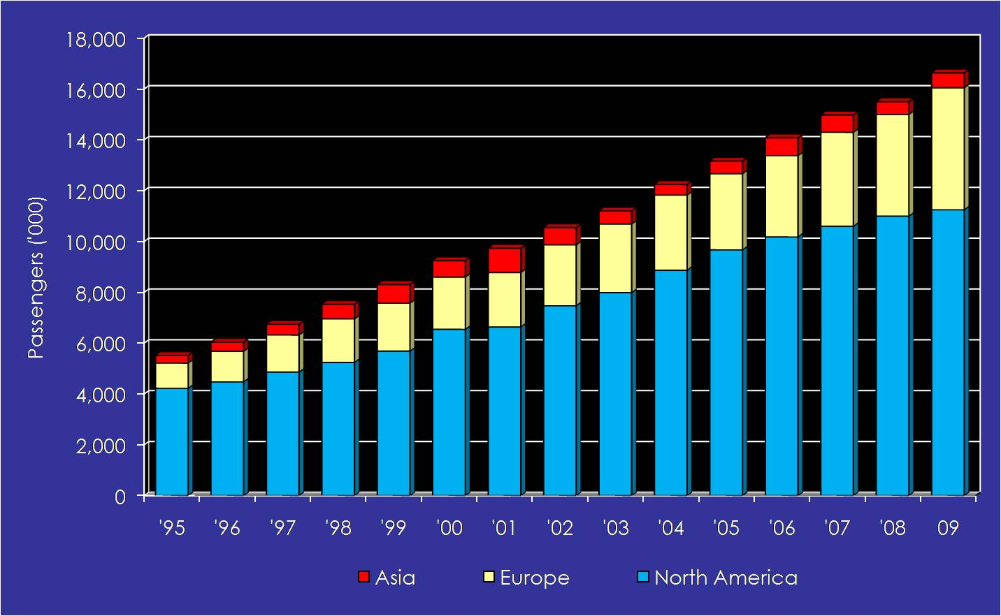
The industry’s continued success over this period is primarily a result of the following:
- Cruise lines created products that work to convert land-based resort guests into cruise passengers. Cruise lines were able to package and mass market an all-inclusive resort package-at-sea that is highly price competitive when compared with similar land-based resort vacations. These all-inclusive packages were marketed through a variety of distribution channels, including travel agents, internet-based retailers, charter operations, and cruise-line-based phone and internet networks. This trend is continuing in the Caribbean region as new larger, exciting cruise vessels with diverse on-board products and services are introduced. In addition, there have been continued efforts to establish new regional itineraries through the development of new destinations and shore-side products to meet the needs of an increasingly broad demographic.
- Cruise operators have effectively controlled competition and operational costs, and have generated revenue streams from several sources beyond net ticket sales. Innovations in cruise vessel design and the move toward larger vessels have allowed cruise lines to reap increased economies of scale. The majority of cruise industry capacity is held by a handful of cruise conglomerates. This factor has served to reduce competition by keeping barriers to entry into the market high; increase leverage on cruise destinations to keep cruise fees low; and allow for significant cost-savings from a high degree of vertical integration throughout the cruise on-board and destination delivery cycle. This trend has been magnified with the creation of a super cruise group – Carnival Corporation -- whose combined brand capacity exceeds that of its next nearest rival by some 30,000 berths and which accounts for over half the new vessels on order over the next five years.
- Cruise industry products consistently deliver a high level of passenger satisfaction. The Cruise Lines International Association (CLIA), through its annual passenger surveying efforts, has year after year reported the cruise experience consistently exceeds expectations on a wide range of important vacation attributes; on a comparative basis versus other vacation categories, cruising consistently receives top marks. Satisfaction with cruise vacations keeps customers coming back; several cruise lines report client retention levels of well over 45 percent. Cruise lines place considerable emphasis on passenger retention, as it is easier and less costly to retain a current passenger than to market to and cultivate new passengers.
- The cruise industry is supply-led in nature, continually increasing passenger throughput by developing and introducing new vessel berth capacity. Over the past decade and more, the cruise industry has grown by introducing new cruise vessels into the worldwide fleet. While some have been smaller niche vessels, the majority have continued to increase in physical size and passenger capacity over the past thirty years. In conjunction with this new-build trend, the industry has concentrated on developing new cruise markets through the introduction of on-board products and services, distribution chains, and other partnerships to fill the vessels introduced to the fleets. With the North American market growing well, the industry has turned its attention to the European cruise consumer market, which has similar demographics as its North American counterpart. As this area expands, the cruise industry has now begun to actively study and participate in the development of the Asia-Pacific cruise market through the enhancement of distribution systems, products, and services for the consumer and the placement of vessels into the region to further stimulate growth. Long-term this may pull some traffic from the Caribbean region on a seasonal basis.

Future Direction of the Worldwide Cruise Industry.
Geopolitical Uncertainties, Economics, and Other Industry Issues: 2001 to 2009. Without question, the events of September 11 and its aftermath created a period of uncertainty and flux, both within the cruise industry and for tourism and leisure providers worldwide. Immediate reactions from the cruise industry included increased financial conservatism, deployment drawback to North American and other home waters, and amplified flexibility in deployment.
By October 2002, confidence was returning. The cruise industry, however, was to face further challenges brought on by a combination of war, terrorism concerns, health issues, and a relatively weak economic outlook. In particular, the Iraq War (March 2003), terrorism threats, and the SARS pandemic in Asia had a dramatic impact on international travel. These major events led to a dramatic collapse in demand for air travel, especially to Asia. This experience was mirrored by the cruise industry throughout the world, but particularly in the Asia-Pacific region, where a number of cruise calls were cancelled and itineraries redrawn to take tonnage out of the region. The current swine flu (H1N1) pandemic scare has also hurt the cruise line industry, initially diverting itineraries from Mexico and generating negative earnings impacts.
At present, the cruise industry is once again under pressure to test its resiliency in a very weak world economy. Cruise industry sensitivities to high expenses, including fuel and port fees, provide a background by which the entire industry must review all aspects of their business and ensure they are prepared to compete in a market that is clearly leaning toward recession. Consolidation of units within each cruise line, greater emphasis on cost control, and a new vision for the marketing of cruises to the public is being considered by each of the major lines.
For the near term, North American and European lines continue to be cautious in deploying their fleet to more distant and potentially less financially productive regions. This is due in part to both a cost increase in regular and low-sulfur content fuels and the subsequent impacts on the purchasing and supply chain for those vessels deployed farther afield from normal North American and European suppliers. To offset fuel costs, many of the lines imposed a $5.00 plus per day fuel surcharge on its passengers in mid-2008, when fuel climbed to more than $145 per barrel in July. As of May 10, 2009, fuel was trading at approximately $58.50 per barrel; however, most industry experts believe fuel will climb again over the next two years to a range of approximately $100 per barrel. There have been minimal impacts thus far on overall passenger growth trends of the industry. Nevertheless, it is clear that the fuel cost issue will affect future deployment trends. No doubt, a premium will be placed on those ports and itineraries that can offer savings to the cruise lines due to speed and distance parameters, fuel supply, tariff incentives, taxation, and additional potential premiums in on-board and shoreside revenues.
Terrorism also continues to be a major point of concern for cruise operators, especially given the high profile of a cruise vessel as a potential target. In November 2005, the Seabourn Spirit was attacked 100 miles off the Somali Coast by pirates with machine-gun fire and rocket-propelled grenades. In August 2004, the UK press reported that a terrorist plot to blow up the Queen Elizabeth 2 during a cruise was uncovered. Similar terrorism concerns and threats exist for all vessel activities in the Straits of Malacca. In early 2008, a French-flagged Ponant Cruise vessel was hijacked off the coast of Somalia. Most recently, in April 2009, an MSC cruise vessel fended off a pirate attack. While cruise operators and ports have radically improved port security, it is anticipated that lines will continue to take a conservative approach with deployment to regions outside the norms – specifically Africa, India, and the Middle East.

Future Market Direction of the Worldwide Cruise Industry. Looking forward at the direction of the market, each of the industry fundamentals responsible for its dramatic rise over the past two decades is expected to remain in place and continue to propel the industry toward long-term passenger and financial expansion. Strong 2008 cruise passenger growth showed marked improvement over 2005 levels and industry experts suggest significant long-term consumer demand also exists in the world marketplace. The short- to mid-term impacts of major world events will, however, certainly cause the cruise lines to further explore their business models, including deployments and supply-chain methods.

Over the past 6 to 12 months, significant new-build orders have been placed which have substantially increased the outlook for additional capacity worldwide through 2010. This increased volume with fewer vessels provides each cruise operator with more flexibility on itinerary and port selection, based on its overall brand fleet size. In combination, however, many ports must increase their infrastructure and tourism-support products to meet the demands of larger vessels in port. Many key cruise homeports and ports-of-call throughout the world are responding by updating their facilities or building new ones.

Barring some unpredictable event, the industry will see continued new-build development through 2010 and beyond. Controlled growth and an emphasis on increased vessel berth capacity and on-board revenue-producing amenities will continue. In this current economic reality, there is little room for any cruise operator to place firm cruise vessel orders past 2011 or 2012 due to a lack of capital, poor exchange rates, and the need to focus on increasing revenues with the existing fleets. Thus, it is likely attention will be turned to shoreside infrastructure to support operations in a cost-effective manner.

New-Build Scenarios. Since industry growth is directly linked to the availability of capacity, several scenarios for cruise vessel supply expansion for North American/European capacity - as measured in vessel berths over the next several years - are provided below. Currently, there is a finite building capacity that is sometimes limited by the shipyards and at other times by the availability of affordable long-term financing.

Scenario 1 (Low). One to three new vessels and an expansion of total supply by an additional 2,375 to 9,500 net new berths per annum.

Scenario 2 (Medium). Four to six new vessels and an expansion of total supply by an additional 9,500 to 15,000 net new berths per annum.

Scenario 3 (High). Seven to ten new vessels and an expansion of total supply by an additional 15,000 to 25,750 net new berths per annum.

The forecast for the growth of North American capacity is presented in Figure 2.6.2. The estimated net berth supply for the next three years is based upon the known cruise vessel deliveries already under construction. Beyond that, the projections use the assumptions listed above for the new orders of vessels that are discussed in Section 2.6.5. These new vessel occupancies are adjusted for the historical 92.5 percent and growth in vessel size shown later in this section and other factors.

As shown, total berth inventories are anticipated to grow from approximately 267,013 lower berths in 2008 to between 407,000 (low) and 611,000 (high) lower berths by 2029. The range of growth per annum is from 1.78 percent (low) to 5.18 percent (high). The projections also include a withdrawal factor of 10 percent of the amount of berths being introduced in any given year to account for the retirement of older capacity. This is based upon historical averages.

Figure 2.6-2

Historic and Projected North American Industry Berth Supply

Source: B&A, 2009
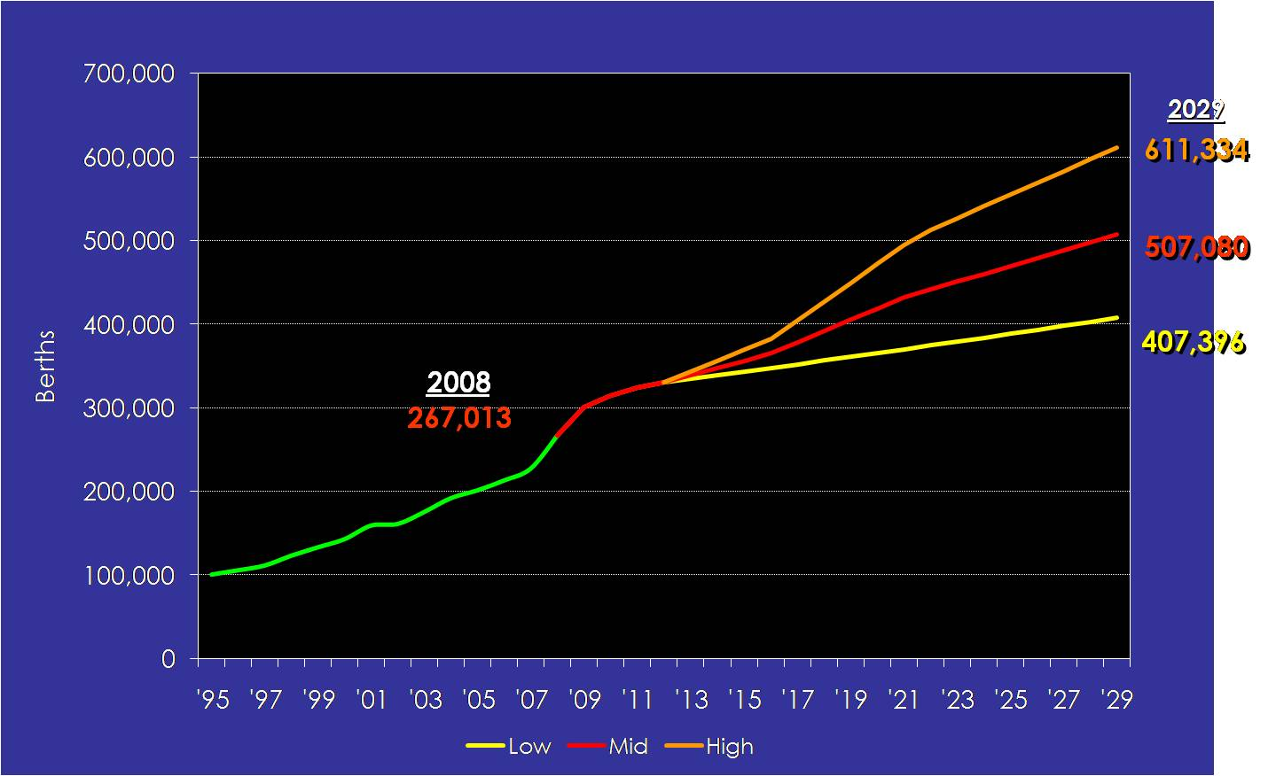
The projected North American passenger capacity levels through 2029 also assume that consumer demand keeps pace with vessel supply over the period reviewed. As cruise operators place cruise vessel orders at a maximum of four to five years into the future, this model is inherently less reliable beyond 2012. Factors for North American capacity are based upon the current average lengths of sailings at 7.1 days.
Based on the availability of ships, the projected number of North American passengers is anticipated to grow to between 15.2 million (low) to 22.9 million (high) by 2029, as shown in Figure 2.6-3. Over the mid-term, it is anticipated that there will be much stronger growth in the European and Asian cruise markets to take advantage of similar factors seen during the strong growth period of the North American cruise market in the 1990s through 2008.

Figure 2.6-3

Projected North American Passenger Levels, 1995 – 2029

Source: B&A, 2009
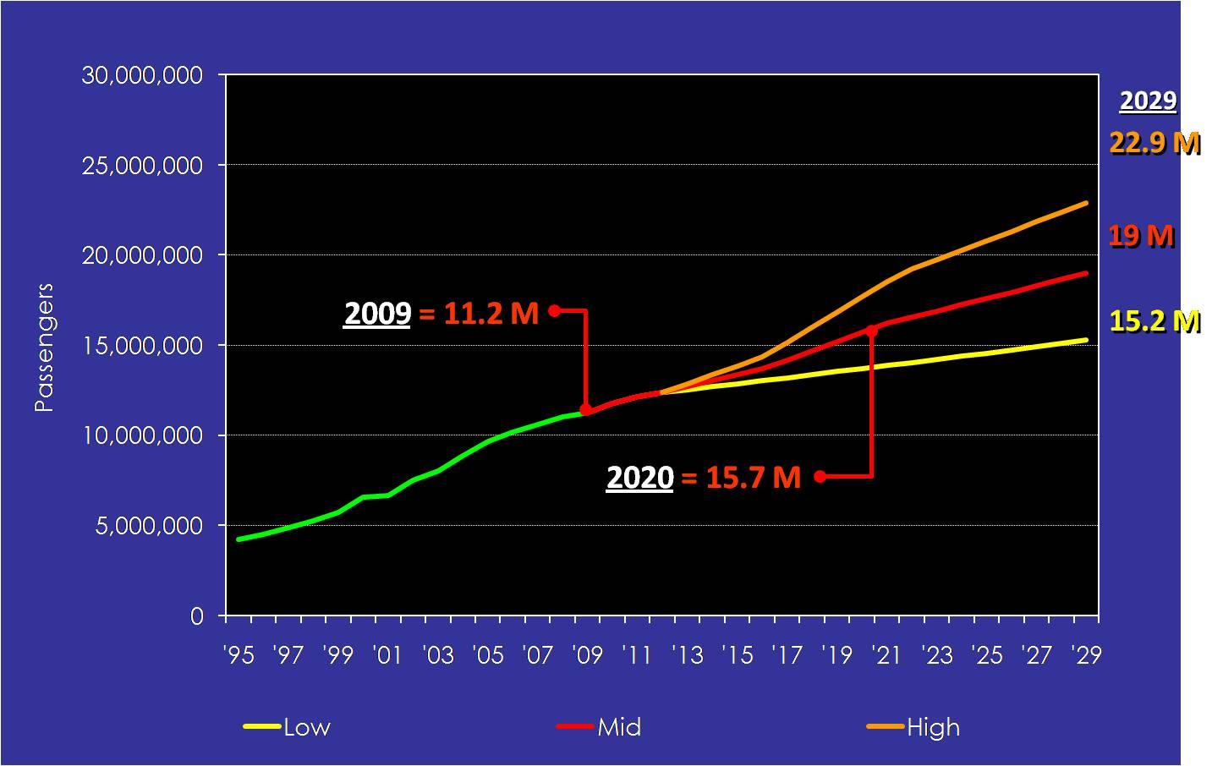

Cruise Lines, Vessels, and Other Industry Characteristics.

Leading Cruise Operators. Today, four major cruise operators dominate the cruise industry worldwide (see Figure 2.6-4). The “big four” were formed for the most part through merger and consolidation to provide each with better economies of scale, progressive marketing options, and increased channels of distribution. At the end of 2008, Carnival Corporation had more than 48 percent of total berth capacity worldwide, followed the other major industry participants: RCCL (24 percent), NCL Cruises (7 percent), and MSC (7 percent). The remaining 14 percent of industry capacity is shared by over 50 cruise lines, ranging from medium-sized lines typically operating between two and five vessels to small cruise line operators with one vessel.

Figure 2.6-4

Cruise Capacity by Cruise Group

Source: Cruise Industry News Annual, 2009
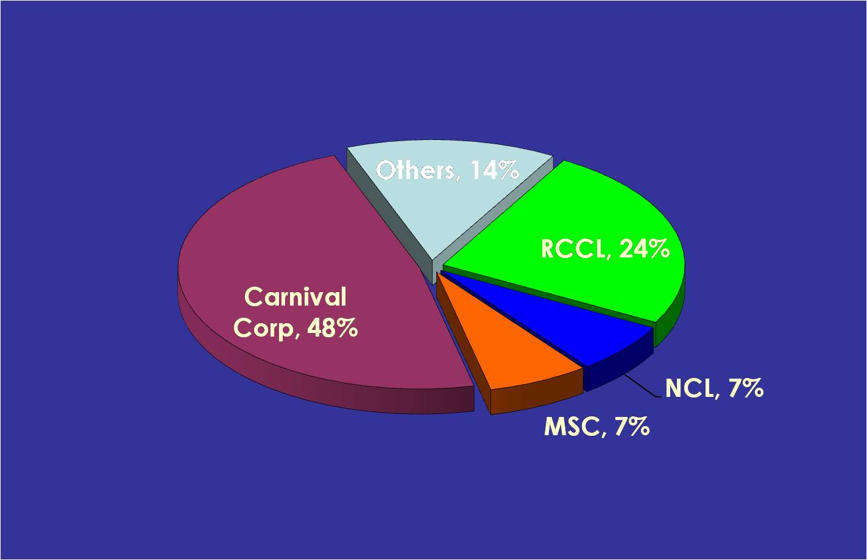
Several attributes of the major cruise lines and of several smaller operators are described below.
- Carnival Corporation. Publicly held and traded, Carnival Corporation controls over 169,000 lower berths on 89 vessels. Carnival Corporation presently has an additional 16 cruise vessels on order through 2012. Their portfolio of 10 brands and additional travel partnerships is remarkable and includes many of the gold-standard cruise companies: Carnival Cruise Lines, Holland America Line, Princess Cruises, Seabourn Cruise Line in North America, P&O Cruises UK, Cunard Line, and Ocean Village in the UK, AIDA in Germany, Costa Crociere in Southern Europe, and P&O Cruises Australia. These brands combine to offer a range of vacation products to consumers with varied tastes, income levels, and national origins. Combined, more than 8 million people sail on Carnival brands annually.
- Royal Caribbean Cruises, Ltd. Under its brands, Royal Caribbean International (RCI), Celebrity Cruises, Pullmantur, Azamara Cruises, Ibero Cruise, Crosiere France, and Celebrity Xpeditions, RCCL operates a fleet of 38 vessels with 6 additional vessels set for delivery before 2012. Current fleet capacity is slightly over 80,000 lower berths. RCCL is also a publicly held corporation. To improve its European presence, RCCL acquired Pullmantur S.A. in 2006. Croisiere France was recently started in 2008 to target the French cruise consumer market. The RCI brand is finally going international with much of its fleet, while deploying Celebrity Cruises to a greater degree to fit an expanded North American clientele. Azamara Cruises was formed to compete against the Oceania, Regent, and Silversea fleets. The RCI brand has a goal of placing a minimum of 50 percent of its fleet into international markets by 2012. This will impact its domestic presence in key markets.
- NCL Cruises. NCL is the third largest cruise line operator in the world. The combined fleet of NCL and NCL America consists of 12 vessels and over 29,000 lower berths. NCL is marketed primarily to consumers from North America. Apollo Management Group invested $1 billion into NCL into 2007. The focus for NCL is expanding revenues and decreasing its overhead situation, particularly in the Hawaiian market where they divested their fleet in 2008. The 4,200-passenger Norwegian Epic will be delivered in July 2010.
- MSC Cruises. MSC Cruises offers mid-class cruises to destinations throughout Europe and the Caribbean. MSC North America is intended to cater to a more upscale, niche market with its vessels. This is a private, family-owned Swiss/Italian company backed by MSC Cargo and privately held by the Aponte family. While MSC has strong financial backing, some industry analysts are hesitant as to what their level of success will be in the North American market due to brand placement. MSC has 10 vessels with 21,600 lower berths. They have 3 vessels on order set for delivery by 2011. Should the MSC Europe headquarters provide the vessel capacity to its North American brand, they may expand into the traditional North American markets long-term. MSC will also pursue more deployments to the European markets and will likely continue to grow in the competing summer Baltic region. MSC wants to pursue more deployments to increase their brand status worldwide.
While lines in the “other” category are far smaller in terms of fleet size, they include a number of important and unique brands that provide increased diversity within the industry overall. Representative lines include:
- Disney Cruise Lines. Disney Cruise Lines is the leading family entertainment cruise provider, with 3-, 4-, and 7-night itineraries to the Bahamas and the Caribbean offered on two cruise vessels (Disney Wonder and Disney Magic). While linking cruise offerings to upland facilities is not unique in the industry, Disney’s combination of family brand and upland theme parks creates inherent interest in their cruise product. In 2005, Disney Cruise Lines took their formula to Los Angeles with 7-night Mexican Riviera cruises during the peak summer season. These cruises were very successful, based on feedback from the cruise line. Disney has placed an order for two new cruise vessels set for delivery in 2011 and 2012.
- Regent Seas Cruises, Oceania, and Silversea Cruise Line are luxury-class cruise lines, offering itineraries throughout the world to a predominantly North American clientele. All the lines are privately held companies by the Apollo Group and Vlasov Group, respectively. At present, Oceania has two vessels on order. Each of these smaller premium lines focuses on European and world cruise destinations as well as seasonal Caribbean sailings.
Brand Types. Similar in composition to the hospitality industry, each major cruise group comprises several cruise line brands with vessels positioned to appeal to different geographic markets and consumer tastes. The majority of cruise brands generally fall into one of the following four segments:
- Luxury. The luxury segment offers cruises of greater than seven days on high quality, small and medium-sized vessels. Luxury vessels tend to sail worldwide and offer superior food and service.
- Premium. The premium segment is geared towards more experienced cruisers, often older and more affluent, with time to vacation. Service and food quality are emphasized under the premium segment.
- Contemporary. Vessels found in the contemporary segment appeal to passengers of all ages and income categories, with a focus on middle-income levels. While this segment has a healthy rate of past-passenger participation (estimated at 30 percent to 50 percent of the industry), this segment is highly dependent on the continued introduction of new cruise passengers to the marketplace.
- Budget. The budget segment tends to be a less expensive version of the contemporary market, with vessels generally older, smaller, and offering fewer amenities. There are a few of these operations in Europe, but none in the US at present. It is unclear, however, whether this segment will be able to continue any growth through the acquisition of older vessels in the major world fleets, with the implementation of SOLAS regulations by 2010.
Several other secondary market segments exist, including exploration and soft adventure cruises, niche cruises, river cruises, and coastal operations. In addition, several tour operators have chartered vessels for their niche market segments.
The majority of Port Everglades’ cruise base comprises capacity from the contemporary and premium segments of the North American market. Port Everglades is, however, in a unique position because its overall offering of cruise products includes all brands and types.

Cruise Vacationers. Although the cruise industry continues to strive toward globalization, the majority of cruise passengers are still sourced from two significant locations: North America and the UK. In 2008, these source markets accounted for more than 80 percent of total worldwide cruise bookings. Continental Europe and Asia provide solid cruise numbers as well, although overall growth has been much slower.

Record cruise bookings were achieved worldwide despite the Iraq War and other security concerns, proving the resiliency and ability of the cruise industry to perform within the overall vacation market. The Passenger Services Association (PSA), the UK-based cruise-marketing group, and CLIA (North America’s cruise-marketing body) have released studies that provide some indication as to the consumer trends of the industry and, more important, the potential cruiser profile that is critical to the long-term success of the industry. Much of the detail provided below is gleaned from these survey reports and other market sources, as indicated.

North American Consumers. Consumer trends continue to be supportive of further industry growth worldwide. Several of these are highlighted below:
- Repeat business is high, with more than 77 percent of North American cruisers planning on taking another cruise vacation.
- Almost 60 million people have cruised at least once in their lives, 30 million within the past three years alone.
- The most likely number of North American cruisers over the next three years is 33 million (with a best-case scenario of more than 50 million), with incomes in excess of $40,000 annually.
- Cruise passengers spent approximately $1,880 per person on a typical contemporary weeklong cruise vacation, inclusive of cruise fare and on-board expenses.
- The average cruiser has taken 3.4 cruises. Based on the cruiser categories defined in the CLIA 2008 study cited below, Destination-driven cruise passengers sail more, with 9.1 cruises, followed by Luxury (8.4), Premium (5.9), and Contemporary (3.7).
- The average age of actual and potential cruise consumers continues to decline (age 48.3 in 1992 vs. 45 in 2008). Household incomes for cruise passengers are high, averaging $93,000 for North Americans, increasing from $58,400 in 1992 and $79,000 in 2000. As products continue to diversify, however, cruising (as evidenced by cruise prospects) continues to be considered by individuals with lower household incomes.
- Approximately 53 percent of cruisers plan vacations at least 4 months in advance.
- Four out of five cruisers (72 percent) are interested in taking a future cruise. More than 43 percent of non-cruisers are interested in taking a cruise in the next three years.
- Destination is paramount in vacation decisions, followed by pricing.
- The Caribbean region ranks first amongst the “Top 12” most appealing places for a next cruise – with the top ten being Caribbean/East Coast of Mexico, Alaska, Bahamas, Bermuda, Hawaii, Mediterranean/Greek Islands/Turkey, West Coast of Mexico, Europe, Panama Canal, and Coastal US.
- Cruising is seen by a large majority of passengers as a good way to sample a geographical area/destination for future vacations. After sampling the geographical areas/destinations on their recent cruises, more than 80 percent say they will return for another type of vacation.
- Nearly all traveler segments name the Caribbean (43 percent overall) as the top area to visit on a cruise, with the exception of prior destination cruisers who place Alaska (21 percent) and Europe (21 percent) ahead of the Caribbean (18 percent). Luxury cruisers are almost as likely to pick European Rivers (24 percent) as the Caribbean (26 percent).
- There is an increasing perception that online travel retailers provide the best cruise prices; travelers most frequently believe that the best price on a cruise can be found on the Internet. Over half (53 percent) cite the Internet as the place for getting the best prices, followed (distantly) by calling the cruise line directly (26 percent), and travel agents (18 percent). Less than one in five cruisers and non-cruise vacationers now believe that the best price is available through a travel agency.
- Cruisers still deem travel agents as the distribution channel that offers the best service (42 percent, essentially the same as last year at 43 percent). One cruiser in four (27 percent) considers the cruise line’s service to be superior. Tour operator service and website/online retailer services vie for the lowest spot of the four choices.
- More than half (59 percent) of cruise-bound travelers indicate awareness of at least one cruise embarkation point. Not surprisingly, the awareness of past cruisers (66 percent) is substantially greater than that of their non-cruiser counterparts (45 percent). Nearly all (92 percent) potential cruisers perceive at least some benefit to having numerous cruise embarkation points, particularly: drive-to convenience (71 percent), cost saving (67 percent), fewer airport hassles (64 percent), and added vacation value (53 percent).
- The more expensive types of cruises tend to host repeaters – for example, three-quarters of Destination (77 percent), Luxury (74 percent), and Premium (79 percent) cruisers sailed more than once. Contemporary lines attract the largest share of first-timers (40 percent). The relatively high proportion (45 percent) of new cruisers into the market, however, indicates that the industry continues to attract new (first-time) passengers and that marketing promotions create new interest.
- Seventy-two percent of likely cruisers indicate that more than one cruise embarkation point increases their likelihood of cruising from a “close to home” homeport.

European Consumer Demand. European consumer trends are continuing to grow, due to the development of products specifically for the consumer markets in the region:
- Passenger growth has averaged 22 percent over the past five years.
- Europe has very similar population and demographic levels as North America, which bodes well for the cruise industry.
- There has been a rapid growth of the UK and German cruise markets over the past three years.
- Products have been tailored to meet the divergent needs of market tastes, inclusive of vessels, products and services, itineraries, and other items.
- Additional growth in cruise line products is seen in Spain, Italy, and France.

Length of Cruise and Seasonality. Over the past 20 or more years, the overall distribution of sailing lengths has been relatively consistent, based on consumer vacation patterns as well as speed and distance issues relative to vessel technology (see Table 2.6-1).

Table 2.6-1

Growth by Length of Cruise, North American Operators

Source: CLIA, 2008

Length of Cruise | 1980 | 2007 | % Growth
2 – 5 Days | 347 | 3,854 | 1011.7
6 – 8 Days | 846 | 6,427 | 659.7
9 – 17 Days | 221 | 2,180 | 886.4
18 + Days | 17 | 100 | 488.2
Total | 1,431 | 12,561 | 777.8
Source: CLIA, 2008

With the continued development of the cruise fleet, new regions, and consumer demands, the trend continues toward shorter cruises. For Port Everglades, this trend exacerbates cruise infrastructure issues, as cruise lines want to offer primarily 6- to 8-day and 4- to 5-day patterns, which fall on weekend travel days.
Additionally, a tremendous industry shift in deployment has occurred over the past five years, impacting the seasonality of major cruise regions, including the Caribbean and European/ Mediterranean markets. Seasons in these and other regions continue to expand as cruise lines push to year-round and longer core seasons to exploit revenue opportunities through deployment to homeports (New York) with direct consumer access and regions (Mediterranean) with higher overall per diems.
Figure 2.6-5 illustrates this trend in cruise line deployments. Port Everglades is affected in two ways: by cruise vessels from the Mediterranean being deployed later in the fall/winter months to the Caribbean market and by New York’s now offering winter cruising to the Caribbean region.

Figure 2.6-5

Worldwide Cruise Region Seasonality

Source: B&A, 2009
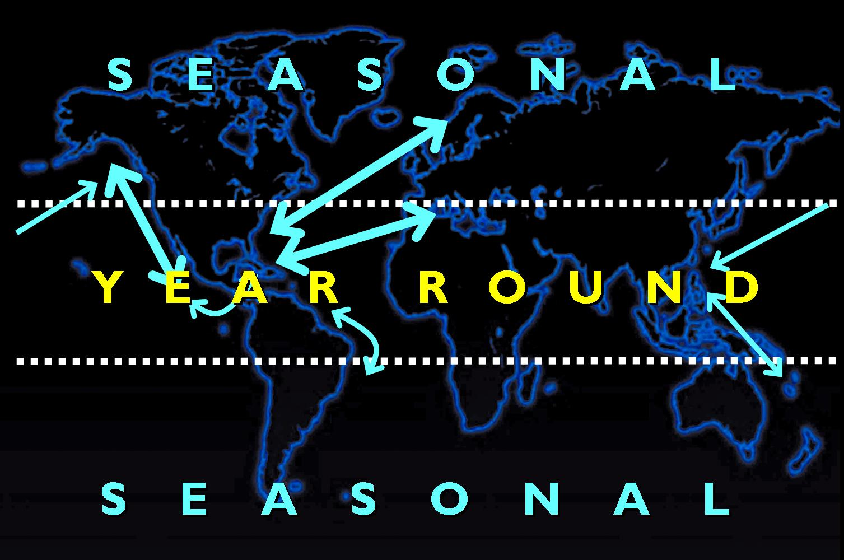

Primary cruise regions. Once focused primarily on the Caribbean and Mediterranean cruising regions, cruise operations are now found around the world. CLIA remains the primary source of detailed data on deployment by cruise sub-regions and, while not inclusive of all operators worldwide, these data provide a good overview of each of the primary cruise sub-regions present in the global marketplace. The Caribbean remains the principal location for cruise capacity placement by all cruise operators, followed by the Mediterranean, Northern Europe, Alaska, and Mexico West (see Figure 2.6-6). In total, over twenty different primary cruise sub-regions are present within the global marketplace, with many of these consisting of even smaller deployment characteristics and typical itineraries.

Figure 2.6-6

North American Capacity Placement by Region

Source: CLIA, and B&A, 2009
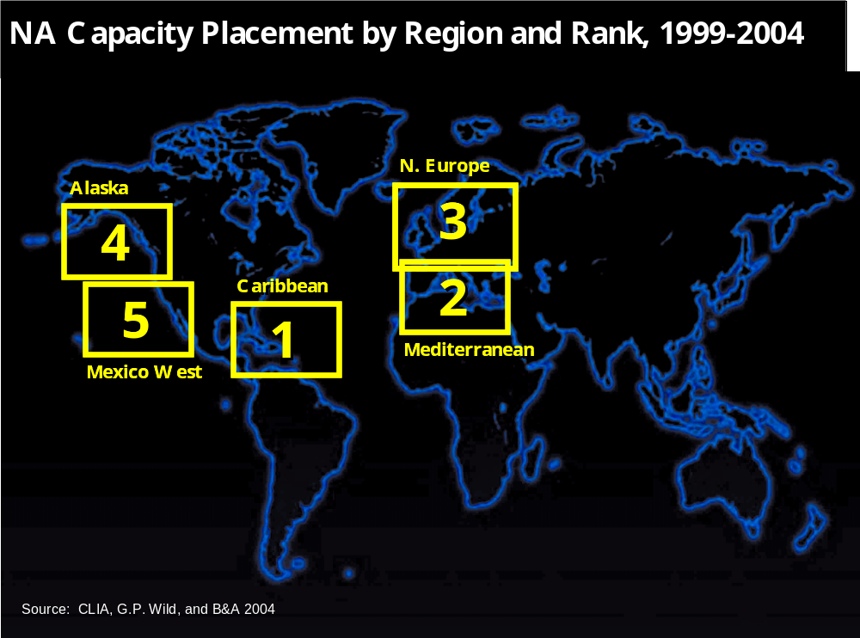

For North American lines, the Caribbean received a significant increase in capacity placement between 1995 and 2007—over 16.4 million bed-nights—resulting from delivery and deployment of several of the industry’s new large vessels. Capacity growth was also very strong in the Mediterranean. The Caribbean region did lose approximately 4.5 percent capacity in 2008. This is likely a cycle and will grow over the next mid-term.
Table 2.6-2 illustrates worldwide cruise market deployments from 2000 to 2008. While the Caribbean produces the largest capacity deployment annually, other regions are growing as well, including the Mediterranean. Each of these sectors is highlighted below to illustrate overall regional deployment trends.

Table 2.6-2
Cruise Capacity Placement by Region, North American Operators
Source: CLIA, 2009
Region | Bed-Nights (thousands) |  |  |  |  |  |  |  |  | % Change 07 to 08
 | 00 | 01 | 02 | 03 | 04 | 05 | 06 | 07 | 08
Caribbean | 21,510 | 21,833 | 26,741 | 28,999 | 31,210 | 31,450 | 31,956 | 32,162 | 30,786 | - 4.5%
Mediterranean | 6,277 | 7,546 | 6,497 | 8,153 | 9,704 | 9,734 | 10,504 | 14,748 | 16,271 | 9.4%
Alaska | 4,197 | 4,698 | 5,052 | 5,265 | 5,913 | 6,417 | 6,356 | 6,927 | 6,968 | 0.6%
Bahamas | 3,200 | 4,698 | 2,876 | 3,305 | 3,656 | 4,397 | 6,072 | 4,634 | 3,477 | -33.3%
Trans Canal | 2,573 | 2,396 | 2,092 | 2,783 | 2,930 | 2,718 | 2,803 | 2,663 | 2,679 | 0.6%
Mexico West | 2,680 | 1,166 | 3,386 | 3,390 | 4,827 | 5,759 | 5,214 | 5,948 | 6,451 | 7.8%
N. Europe | 3,744 | 4,837 | 6,922 | 7,721 | 7,560 | 5,522 | 6,799 | 6,798 | 7,592 | 10.5%
Bermuda | 988 | 1,269 | 1,226 | 1,476 | 1,324 | 1,329 | 1,388 | 1,285 | 1,266 | -1.5%
Trans Atlantic | 1,015 | 1,129 | 1,005 | 1,145 | 1,425 | 1,747 | 1,467 | 2,209 | 2,830 | 21.9%
Hawaii | 857 | 1,557 | 1,903 | 1,953 | 2,629 | 2,907 | 2,885 | 3,826 | 3,031 | -26.2%
South Pacific | 1,155 | 1,158 | 835 | 1,099 | 683 | 657 | 1,448 | 1,013 | 1,986 | 49.0%
SE Asia | 244 | 429 | 346 | 123 | 20 | 58 | 610 | 431 | 527 | 18.2%
Africa | 502 | 401 | 259 | 188 | 17 | 67 | 42 | 25 | 137 | 81.8%
Canada / New England | 1,107 | 1,138 | 1,150 | 1,105 | 1,488 | 1,174 | 1,233 | 1,627 | 1,911 | 14.9%
Far East | 201 | 215 | 360 | 219 | 403 | 644 | 127 | 923 | 527 | -75.1%
Mississippi | 347 | 403 | 0 | 0 | 0 | 0 | 0 | 169 | 137 | -23.4%
World | 414 | 613 | 582 | 375 | 462 | 460 | 339 | 804 | 1,063 | 24.4%
S. America | 825 | 1,422 | 1,394 | 1,653 | 1,088 | 1,417 | 1,446 | 2,129 | 2,676 | 20.4%
Coastal West | 217 | 1,944 | 216 | 376 | 643 | 433 | 161 | 229 | 225 | -1.8%
Indian Ocean | 120 | 227 | 93 | 23 | 10 | 38 | 10 | 70 | 229 | 69.4%
US East coast | 1,402 | 80 | 147 | 837 | 60 | 34 | 80 | 153 | 83 | -84.3%
Other | 277 | 411 | 492 | 488 | 1,235 | 211 | 605 | 934 | 1,186 | 21.2%
Totals | 53,862 | 59,581 | 63,585 | 70,685 | 77,298 | 77,230 | 81,454 | 89,707 | 91,990 | 2.5%
Source: CLIA , 2009

While contributing to the overall market capture sphere, the Transcanal, Bahamas, Transatlantic, and World segments contribute much smaller amounts to cruise traffic at Port Everglades. Based on cruise line feedback, it is envisioned that growth will continue for the region at a slower pace than comparable competitive world cruise regions over the short- to mid-term.

Global Growth Trends Summary.

The cruise industry is primarily constrained by ships (supply), not passengers (demand).

Due to the saturation of traditional ports and regions, and in an effort to satisfy repeat clientele demands, cruise lines are expanding operations in several cruise regions.

Non-US passengers are taking more cruises, with the focus on Europe and Asia.

Increasingly, the cruise industry is controlled by a handful of very profitable operators, which are intent on refining their business plans and financial models to better satisfy the requirements of a public sector corporation.

Industry growth is generating opportunities for port development and infrastructure expansion worldwide.

Overall, the industry is generally recession-resistant, with cruise lines able to shift capacity from longer to shorter, closer-to-home, more affordable cruise segments. Key items of focus for the cruise line industry include continuing to expand on-board revenue options, controlling more of the expense side (food and beverage, port fees, regulatory costs, maintenance, and fuel), expanding consumer bases, and streamlining the consumer supply chain.

Primary Cruise Target Regions. The main target cruise regions for Port Everglades include the Caribbean and sectors within the region, as identified in Figure 2.6-7.

Figure 2.6-7

Primary Caribbean Cruise Target Sectors

Source: B&A, 2009
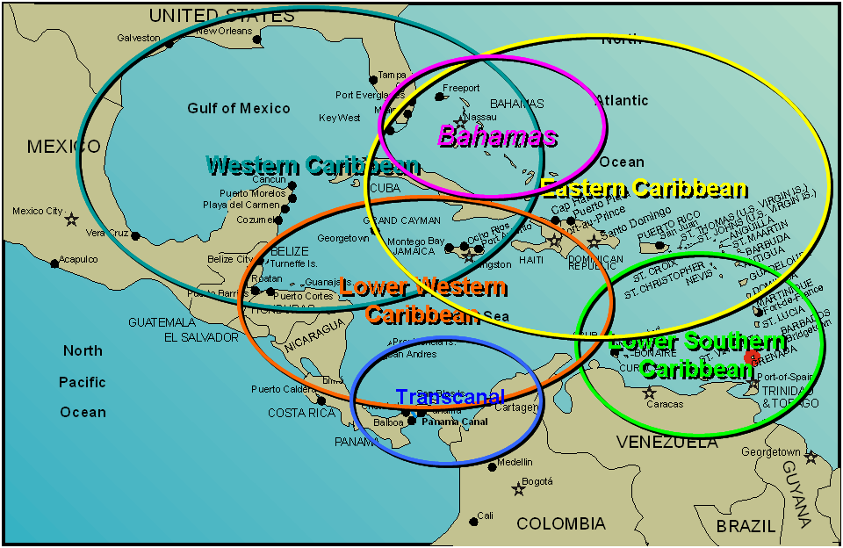

The Caribbean region accounted for a third of North American total bed capacity worldwide in 2008. It is reasonable to conclude that, from a North American operator’s perspective, the region has benefited from the expansion of the cruise market and the diversification of itineraries. Nevertheless, this trend has also meant that overall competition for traffic has expanded beyond the typical winter cruise regions to include European and Mediterranean sectors. Why? Cruise industry interviews and others sources suggest that, at present, the market is accessible and less costly for vessel operations targeted to North Americans via New York and Boston homeports.
North American operators have had success in understanding how to market and develop cruise products that appeal to the tastes of many diverse consumer groups. These operators suggest there are still opportunities within the Caribbean cruising region; as such, this region will be one of the many focuses of their development in the mid- to long-term. For instance, the development of Cuba, offering a series of cruise ports, and the continued development of new destinations throughout the region will bolster mid- to long-term interest in the region by cruise lines, and more important, by consumers. Cruise line deployments will also continue to be based upon outside influences directly related to other potential markets in Europe and Asia as these begin to open and develop. It is not believed, based upon cruise line interviews, that the introduction of the Cuban market at any point will have a dramatic effect on increased capacity from the South Florida market. This eventuality will, however, assist the Caribbean region in maintaining its dominance. Additionally, long-term opportunities for passenger ferry service are likely to be limited, as the airline industry will capture much of the market to the dispersed cities on the island. There is, however, an opportunity in the short-term for ferry RO-PAX and RO-RO services to move people, vehicles, and construction supplies to the island community.
As shown above, the primary Caribbean sectors provide excellent options for sailings that fall within the traditional North American consumer’s vacation patterns. While the total number of North American homeports has expanded considerably over the past five years, both Port Everglades and the Port of Miami continue to be the key homeport links to the Caribbean. Bahamas and Transcanal cruise offerings are also included in this analysis, as they are often combined with Caribbean destination offerings.
The Caribbean region has continued to evolve over the past several years as the cruise line industry, in conjunction with Caribbean and Central American destinations, has introduced new ports, vessels, and itinerary patterns to further entice and expand the North American and European consumer markets. The Caribbean market is no longer limited to popular ports-of-call accessible within an 8- to 15-day sail from South Florida, essentially destinations found in the Bahamas and Greater Antilles island chains. The maturation of the Caribbean as a cruising region over the last twenty-five years has resulted in a broadening of cruise itinerary offerings and cruise operation sub-regions.
Since 2001, numerous new homeports in the Gulf of Mexico have produced additional cruise opportunities for North American consumers. In addition, the North American and European cruise line industries have actively looked to open new homeports in places such as Barbados, Puerto Rico, the Dominican Republic, and Mexico West to further access the deeper Caribbean. The continued development of these homeport areas along with the impacts of new ports-of-call in the Caribbean and Central America will continue to encourage the growth of the region overall.
Five primary Caribbean cruise sectors generate homeport operations for Port Everglades. Six other segments of the worldwide market also contribute differing levels of cruise traffic to Port Everglades. They include:
- Western Caribbean. Today, this sector has the highest capacity offering in the Caribbean, with three primary destinations (Cozumel, Grand Cayman, and Jamaica). In addition, most major lines also offer a private island opportunity. While considerable congestion occurs in these major ports, cruise lines are continuing to address this issue by developing new ports and infrastructure to serve growth requirements. This pattern can be operated with 5-, 5-, 4-day patterns.
- Eastern Caribbean. This region is the “bread and butter” run of the Caribbean, consisting of the main ports of San Juan, St. Thomas, and St. Maarten. The industry is continuing to expand offerings with new destinations in the region such as Antigua, St. Kitts, and others. Typically, cruise lines have offered rotating Eastern and Western sailings from Port Everglades.
- Lower Southern Caribbean. From a geographic perspective, the Lower Southern Caribbean region extends from South America east to include the Windward Islands (also referred to as the West Indies). Typical ports visited on North American and European line itineraries include St. Thomas, Aruba, La Guaira, Dominica, Curacao, Barbados, St. Kitts, and Martinique. An overall high level of consumer demand by European travelers has significantly increased European cruise operators’ presence in the region in the past three years.
- Grand Caribbean. The Grand Caribbean itinerary generally includes itineraries of 10- to 14-days duration. For both European and North American cruise operators, these itineraries often embark from homeports in the US — primarily Port Everglades, the Port of Miami, the Port of Tampa, and the Port of New Orleans — and travel to a greater variety of both traditional and non-traditional southern Caribbean destinations.
- Extended Caribbean/South America. Itineraries in this infrequently operated market sector generally comprise a seasonal vessel’s repositioning movement between the Caribbean and the emerging (deep) South American cruise sector. A few lines also offer a limited number of open-jaw cruise itineraries.
- Transatlantic. Transatlantic itineraries are used in the repositioning of the North American and European fleets from European summer cruising regions and as a transition of capacity into the winter market in the Caribbean. Since these sailings do not typically generate significant revenues for cruise lines and are used primarily to move the ships into seasonal markets, this cruise segment is unlikely to see significant growth.
- World Cruise. The world cruise market is very limited and caters to wealthy passengers who can be away from their homes for an extended time. These sailings are typically 80 to 120 days in duration, divided into more modest 15- to 24-day cruise segments. The cruises pass through regions of the world as they navigate the globe; thus, all calls on the itineraries are usually one-off calls (i.e., they do not repeat ports). In addition, these sailings are also seen as exotic and do not spend a significant amount of time in the larger cruise markets such as the Caribbean.
- Bahamas. Mainly comprising offerings in Nassau, Freeport, and a private island experience, this sector has seen fluctuating fortunes over the past several years. Much of this fluctuation is due to low passenger and cruise line satisfaction levels. New products in Nassau and a potential new cruise port in Freeport may, however, help alleviate some of these problems. Should Cuba open at some point, it is likely that the Bahamas would be hit hardest in terms of potential loss of cruise vessel traffic.
- US East Coast Repositioning. This is a very small market sector, comprising those sailings from / to the Northeast region of the US. Mainly used for moving vessels to and from the Caribbean market, growth is limited due to cabotage limitations and market conditions. Mainly smaller US-flagged vessels with no impact on Port Everglades sail this route from Charleston north to Canada.
- Daily and Non-Conventional. This assessment grouped gaming/entertainment daily cruises (Discovery / Bahamas Celebration). Discovery Cruises offers cruise transfers to the Bahamas, with the ability to move cargo; and Bahamas Celebration offers 3- and 4-day sailings to the Bahamas. Each of these operations participates in its own niche market within Port Everglades and the South Florida region. Based on analysis and stakeholder input, growth factors for this sector of Port Everglades traffic are incumbent upon the following:
- Requirement for a designated berth / terminal and RO/RO ramp placement would assist in marketing efforts and cost containment.
- Expansion of the cruise and ferry market with a potential Cuba opening may impact opportunities available for these operations within the region. This is, however, a very speculative topic and of little analytical value in the short-term, as discussed above.
- For Discovery, the viability of its vessel due to age and SOLAS regulations will limit options in the mid- to long-term. Demand for older vessels will likely continue to decrease over time, as newer vessels worldwide are placed into the marketplace.
- Additional regional tourism competition from gaming, entertainment, and large retail venues will likely continue to erode the future opportunities for limited daily and non-conventional cruise operations.

Fit of Port Everglades within Identified Target Markets. Each of the target markets identified above affords Port Everglades varying degrees of potential homeport operations. Port-of-call operations to Port Everglades are extremely limited due to the Port's extensive homeport and daily and non-conventional, traffic; they provide less than 16 percent of all throughput annually.

Table 2.6-3 summarizes the Port’s general potential for participation in each of the target markets reviewed. The Port’s strategic position in each market was assessed as being strong (), fair (), or weak ().

Table 2.6-3

Fit of Port Everglades within Identified Target Markets (Summary)

Source: B&A, 2009
Target Market | Homeport | Port-of-Call
Western Caribbean |  | 
Eastern Caribbean |  | 
Lower Southern Caribbean |  /  | 
Grand Caribbean |  | 
Extended Caribbean/S. America |  | 
Bahamas |  | 
Transcanal |  /  | 
Transatlantic |  | 
World |  /  |  / 
US East Coast Repositioning |  |  / 
Daily and Non-Conventional |  | N / A
Key: Strong (), Fair (), Weak ()

As presented above, Port Everglades’ strength in terms of strategic fit is to serve as a key homeport for any of the regional deployment areas discussed, with the ones showing the most promise being the Caribbean sectors long-term.

North American Capacity Placement and Future Projections for Port Everglades. As illustrated in Figure 2.6-8, the majority of bed capacity placement for North America affecting Port Everglades has occurred in the Caribbean and Bahamas cruise regions. Combined, these regions have grown to more than 34.1 million bed-nights and can continue to see growth ahead.

Figure 2.6-8

North American Capacity Placement

Source: CLIA, B&A, 2009

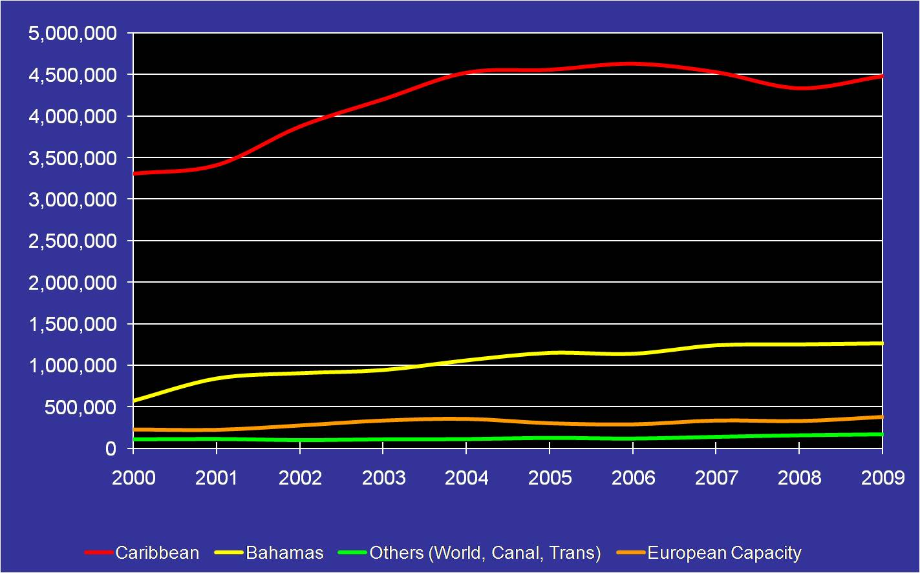
To project the potential growth of Port Everglades and determine opportunities and threats for the Port’s cruise traffic, which is derived mainly from the Caribbean region, one must first look at the future growth of this region. Listed below are several factors impacting Caribbean growth:
- North American cruise operators are trending towards the development of regional US homeports (e.g., New York, New Orleans, Mobile, Tampa, and Baltimore) and key Caribbean homeports (e.g., the Dominican Republic / Mexico) to reach the lower Caribbean ports to further expand the market and ease congestion in the region.
- Carnival Corporation controls the vast majority of all beds in the region, thus controlling much of the future deployments.
- NCL is continuing to focus on the development of the US market through its branding and flagging efforts. This expanded presence, bolstered by new ship deliveries, will likely positively impact Port Everglades as the line focuses on this core market. This impact is dependent on the Port of Miami’s ability to satisfy NCL’s berthing needs with existing or expanded facilities.
- Princess Cruises is opening new lower Caribbean territories through itinerary development and deployment practices. Historically, Port Everglades has served as the long-haul cruise homeport for this market.
- RCI is moving toward the deployment of larger ships in the marketplace; this will impact Port Everglades in the short-term with the introduction of the Oasis of the Seas (2009) and Allure of the Seas (2010) to the Port.
- There is a revised focus on Central American and new Caribbean destinations such as Belize, Honduras, the Dominican Republic, Bahamas, Mexico, and others to assist in the expansion of the market.
- Should Cuba open to North American tourism, this change will certainly impact cruise tourism by increasing the potential port options over a period in the Caribbean. Cuba alone will not, however, necessarily provide a substantial shift in regional capacity.
- To continue the expansion of the Caribbean region, both homeport and port-of-call infrastructure development is needed to accommodate the large next generation of cruise vessel.
- Expansion of out-islands and alternative destinations is key to continued growth of the region, revenue enhancement for cruise lines, and service control.
- Growth will be determined by continuing a trend of larger cruise vessels offering short sailings of less than 8 days, and primarily a 5-, 5-, 4-day pattern.
- Historical capacity placement data indicate regional fluctuations on a year-to-year basis, with the long-term trend suggesting a range from stability to growth (see Figure 2.6-9). Several additional short- to mid-term trends add weight to an overall positive outlook for the Caribbean region most affecting Port Everglades’ cruise throughput.
The region is not, however, without its challenges. Expanded commitment by cruise lines over the long-term will be incumbent on their mid-term success in marketing cruises, developing products that appeal to diverse consumer groups, and ultimately, selling cruises at per diems competitive with other worldwide regions.
With these opportunities and challenges in mind, a trend progression analysis was conducted to project those regions of importance for market growth through 2029. This is a simplistic scenario, but, based on the size of Port Everglades’ cone of capture, it provides a sufficient means of gauging the anticipated growth of those regions overall.

Results from the trend projection presented show passenger capacity in the Caribbean region could conservatively expand from 6.2 million in 2009 to 10.2 million annually by 2029. Estimates range from a 1.16 percent to 5.34 percent annual growth for the regions of importance over the planning period to 2029. This projection bodes well for Port Everglades’ future cruise tourism growth opportunities.

Figure 2.6-9

Regions of Importance to Port Everglades, Caribbean, and Bahamas Passengers, 2000 - 2029

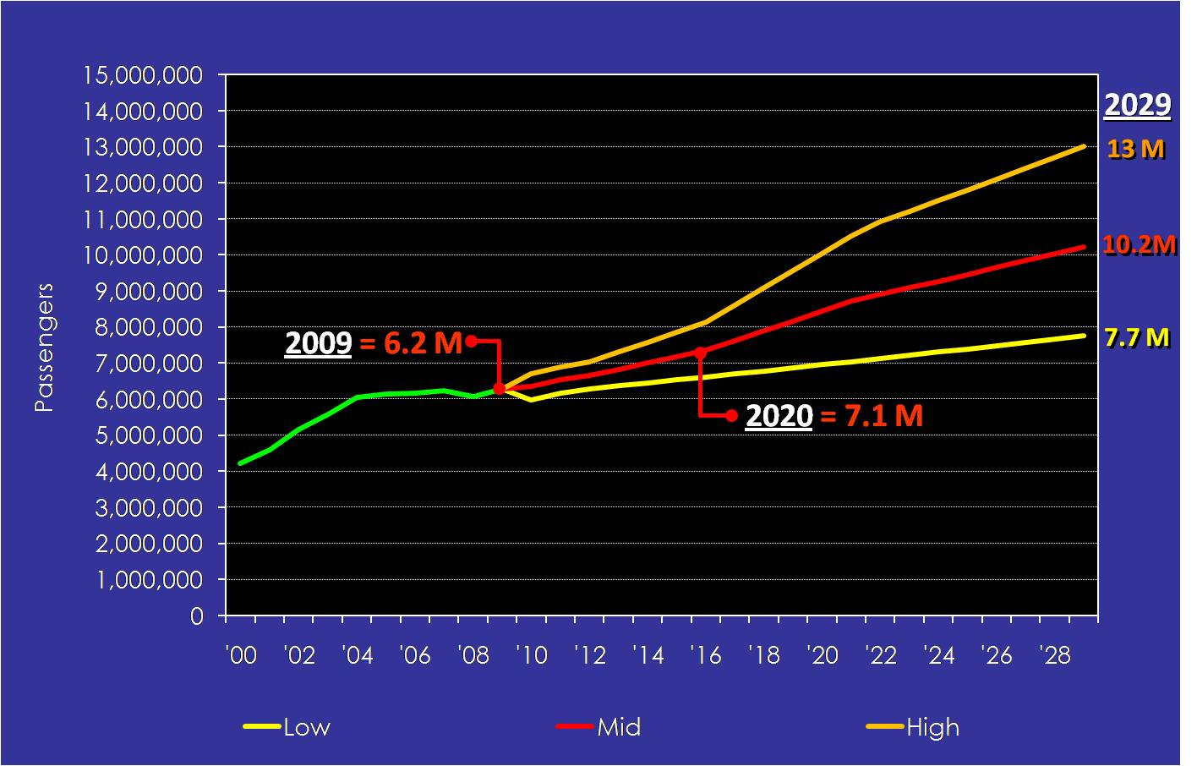
Source: CLIA, B&A, 2009

2.6.3 Port Everglades Current Situation

Section Summary. This section provides a brief overview of the current situation at Port Everglades relating to cruise tourism activities. Port Everglades has shown consistent growth over the past 15 years as a leading homeport for cruise operations to the Caribbean and other destinations throughout the hemisphere. In FY 2009, more than 2.6 million conventional, i.e., multi-day, cruise passengers are expected to sail from Port Everglades on all of the major cruise lines, including European and North American brands, and some 500,000 passengers are expected to sail on daily and non-conventional sailings. By comparison with its nearest competitive port, the Port of Miami, Port Everglades offers a greater variety of sailings due to its many cruise brands (luxury to budget); itinerary variations (daily to 120-day sailings); vessel types (Discovery to Oasis of the Seas; and other factors.
- Cruise passenger throughput has increased by 12.8 percent annually over the past 10 years (1.28 percent total).
- Passenger throughput peaked in 2004 at 4,075,120 passengers. In the next two fiscal years, Port Everglades will see a guaranteed influx of passengers of more than 1.2 million due to the deployment of RCI’s Oasis of the Seas and Allure of the Seas.
- Port Everglades’ trend is towards a slight decrease in multi-day cruise calls with larger vessels deployed to the Port.
- Daily and non-conventional cruises are a “wildcard” for the Port, due to Florida gaming regulations, vessel ages, SOLAS regulations coming into force in 2010 for these older vessels, and other competitive local influences.
Cruise Line Requirements for Port Selection. To assess the cruise tourism infrastructure for Port Everglades, it is important to understand cruise line criteria in making deployment decisions. Their selection of homeports and ports-of-call generally falls into three categories:
- Appeal as a travel and leisure destination.
- Type and quality of cruise tourism infrastructure needed to support vessel operations and movement of passengers.
- A market basis and strategic fit within a greater vessel deployment scheme.
Lines are focused on developing products that deliver high levels of satisfaction and a vacation experience superior to land-based options. The cruise vessel and itinerary are the primary tools lines use to achieve this goal.
Cruise lines and their respective decision-making groups — marketing and sales, marine operations, logistics, and finance — expend significant effort in evaluating a destination, and congruently, an itinerary, to ensure it meets the various criteria established to differentiate their respective product offerings and sell desirable and profitable cruise products. A general list of cruise line decision-making groups and their primary focus in the selection process is provided in Table 2.6-4.
Marketing and sales, followed by marine operations, are the driving forces in cruise line decision-making. The essential concern of the marine operations group is the actual functionality of a destination and itinerary in accommodating their cruise vessels:
- Can the vessel maneuver into the port and complete docking operations safely at the selected pier?
- Are the upland facilities capable of accommodating the needs of the vessel, passengers, and crew?
- Are the region and port safe?
These and other questions are central in marine operations’ evaluation of a destination and itinerary.

Table 2.6-4

Destination Selection: What is Important to the Cruise Lines?

Source: B&A, 2009

Marketing and Sales | Marine Operations
Consumer awareness and marketability of a cruise destination  Access to consumers  Fit with cruise brand philosophy  Fit with consumer vacation patterns | Marine navigation and access  Berth, apron and terminal features  GTA and parking  Provisioning and Security  History of operations from the port
Landside access  Airlift  Lodging  Shore excursions and destination venues | Terminal charges  Labor, fuel and other operating costs  Regulatory issues  Maritime law
Logistics, Air-Sea and Shore Excursions | Finance and Legal

Cruise lines have different needs for port-of-call and homeport operations. Accordingly, cruise line decision-making groups focus on different attributes for each type of facility and destination. Similarly, a cruise terminal is a much greater element of the homeport process; terminals are generally not needed at a port-of-call, as the majority of cruise passengers want direct access to the shore-excursion programs via ground transportation areas, access to taxis and public transportation, or access to tourism and shopping areas. The marine/land operations group will spend time reviewing and evaluating a homeport destination as to the suitability of its cruise terminal to support vessel and passenger operations.
Cruise lines are also concerned with assembling destinations that are complementary to one another on an itinerary. Ideally, destinations visited need to be a balance of shopping, natural areas, and cultural and historical attractions, among other amenities. Destinations have greater influence on ensuring that their cruise tourism infrastructure meets cruise line requirements for vessel placement and the operational fit within an itinerary pattern. Through improving these attributes, destinations can improve their chances of being included in an itinerary and having certain types of vessels operate from/to their port.
For Port Everglades, the primary focus of cruise operations is homeport logistics. This can be defined as the ability to move passengers efficiently and effectively between the vessel and shore and through a ground transportation area (also called the intermodal zone, as discussed in Element 3) that offers the safe and practical marshaling of coaches and other forms of transportation, as required to the airport, local hotels, or home via private vehicle. Secondarily, for the Port’s minimal amount of port-of-call visits, the focus is on the movement and satisfaction of independent cruise visitors and crew and their ability to spend a reasonable amount of time in the port-of-call.
Successful Destination Characteristics. Whether homeport or port-of-call, successful cruise destinations have two basic features in common:
- “Supply Side” Characteristics: Those items that attract and retain cruise lines and passengers to a destination.
  - Regional and/or international appeal as a travel/leisure destination.
  - Cruise tourism infrastructure needed to support vessel operations.
- “Demand Side” Characteristics: A market basis or strategic fit within a greater cruise ship deployment.
  - As outstanding a destination is in terms of cruise tourism offerings and facilities, it must fit within a greater deployment, operational and regulatory scheme to be a viable option.
Port Everglades provides both the supply and demand side of the equation for cruise line deployment due to its overall tourism infrastructure. Assets include an accessible international airport and hotel venues within proximity to the Port, the appeal of South Florida as a travel destination, and the Port’s ability to accommodate a large number of vessels on peak days and provide accommodations for the largest vessels in the present worldwide fleet. Additional primary strengths of Port Everglades include:
- Access to regional consumers. Port Everglades and South Florida in general offer a strong regional base of consumers for cruise operations, both daily and non-conventional as well as conventional multi-day sailings.
- High quality tourism infrastructure and tourist offering. Broward, Miami-Dade, and Palm Beach Counties are well known for their ability to accommodate visitors to the region through a variety of quality tourism infrastructure, comprising airports, hotels, retail venues, and other entertainment facilities, all within proximity to Port Everglades via major roadways.
- Deepwater marine access. Port Everglades provides an entry channel able to accommodate the largest cruise vessels currently operating and those planned for future deployment to the region overall. The short distance from pier to international waters is also of great benefit to cruise lines, allowing for lower expenses and additional flexibility in speed and distance issues involving itinerary planning.
- Number and length of cruise berths. At present, Port Everglades provides seven berths of approximately 1,000 feet in length, with the upland terminal facilities to support vessels approaching 2,500 to 3,000 passengers. The ability to support future vessels is an important factor in Port Everglades’ growth ability over the long-term.
While Port Everglades boasts a considerable ability to service cruise vessels, elements of the present cruise operation call for further improvement. These include:
- Capability of terminals to receive largest cruise vessels. The Port currently has the capability to accommodate large cruise vessels. Based on the cruise vessel new-build order book, cruise line trends, and stakeholder interviews, to be competitive in the region for homeport operations, it is imperative that Port Everglades further develop the capability to serve as a homeport for the next generation of cruise vessel. This is being accomplished through the development of Terminal 18 to support the largest cruise vessels in the fleet.
- Availability of additional berthing areas on peak days of operation. Cruise lines tend to deploy vessels based on consumers’ vacation pattern demands, with weekend departures and returns to the homeport. For Port Everglades, this means assembling the infrastructure capable of accommodating a large number of cruise vessels, passengers, vehicles, and services on peak weekend days and within peak seasons.
- Ingress/egress issues impacting cruise operations and parking. Port Everglades gleans approximately 60 percent of its cruise passengers through airlift and the remaining passenger capacity through private vehicle transfers from Fort Lauderdale-Hollywood International, Palm Beach International, and Miami International Airports. This means large numbers of coaches, taxis, limousines, private vehicles, service vehicles, employee vehicles, provisioning trucks, and others enter and exit the Port on peak cruise days. The Port’s ability to efficiently and effectively allow for expeditious movement of these vehicles, while maintaining security requirements, is a key to future operational growth. Additionally, the ability for the terminal ground transportation and parking areas to accommodate the increased numbers will also be a factor in the Port’s success.

Present Port Everglades Cruise Activities. Figure 2.6-10 shows revenue cruise passenger growth over the past ten years. Using revenue passengers as the basis for analysis helps project and assemble the implications of growth for Port Everglades. This volume both provides an accurate accounting of the actual numbers of passengers utilizing facilities on given days and illustrates the Port’s annual passenger fee charge.
As illustrated, actual revenue passenger numbers have increased over the period with some fluctuation. For multi-day sailings, changes have been seen mainly from a brand perspective that is not a reflection on the ability of Port Everglades to accommodate or provide the necessary services to the line. Some traffic displacement has been due to the increasing Mediterranean seasonality, which provides for a delay in returning or moving larger ships to the region. This trend is likely to continue into the mid-term. On the daily and non-conventional side, capacity has dropped due to the discontinuation of certain cruise operations and an overall decline in the factors that provide for the impetus of this cruise type.

Figure 2.6-10

Cruise Revenue Passenger Throughput, FY 2000 - FY 2009

Source: B&A, 2009
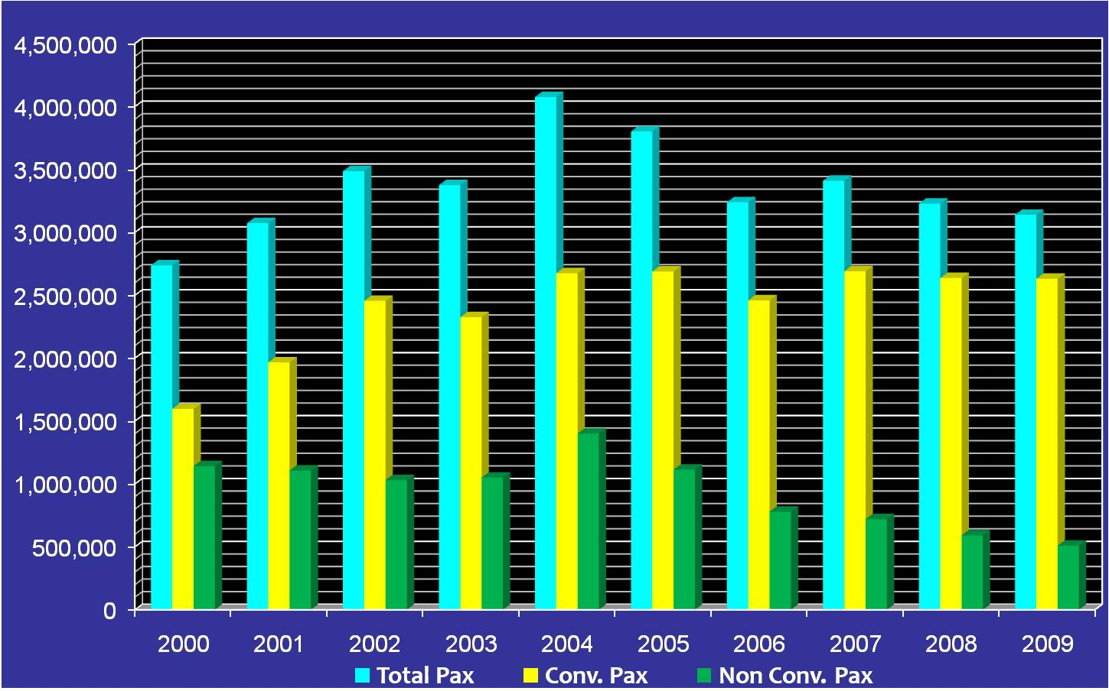

Cruise vessel throughput peaked in 2004, with more than 2,800 cruise calls to Port Everglades. Over the past six years, more than 1,800 sailings have been lost, mainly due to the daily and non-conventional cruise market drop and to a lesser extent the replacement of smaller ships in favor of larger vessels on multi-day cruises.
In FY 2009 specifically, approximately 3.1-million passengers on 977 sailings will depart from Port Everglades. Princess, Carnival, and RCCL are the primary operators. For 2010, Carnival Corporation will be the largest cruise participant at Port Everglades, with more than 58 percent of the total multi-day passengers. RCCL is second with 33 percent of total throughput. Daily and non-conventional cruises contribute 16 percent of total throughput for Port Everglades. Figure 2.6-11 provides an overview of the anticipated 2010 cruise picture, as broken down by the primary cruise lines.
.

Figure 2.6-11

Cruise Line Activity, FY 2010

Source: B&A, 2009
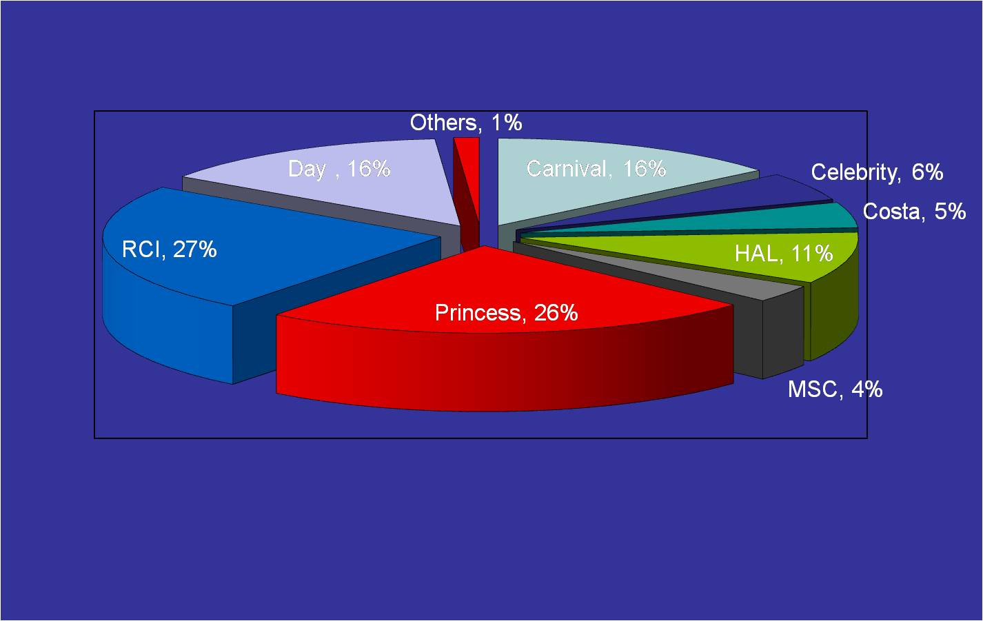
The overall number of cruise calls to Port Everglades has decreased significantly over the past several years. This drop in vessel calls is, however, offset by the increase in revenue passenger capacity of the vessels calling at the Port. This trend poses a considerable challenge to the Port if it is to meet the logistics associated with the increased passenger levels of the cruise vessels primarily calling on the peak weekend days during the winter cruise season. As shown in Figure 2.6-12, a significant increase has occurred in the overall vessel passenger capacity for the conventional vessels sailing from Port Everglades, with an average of some 2,256 passengers per vessel in FY 2009.

Figure 2.6-12

Revenue Cruise Passengers per Vessel, FY 2000 - FY 2009

Source: B&A, 2009

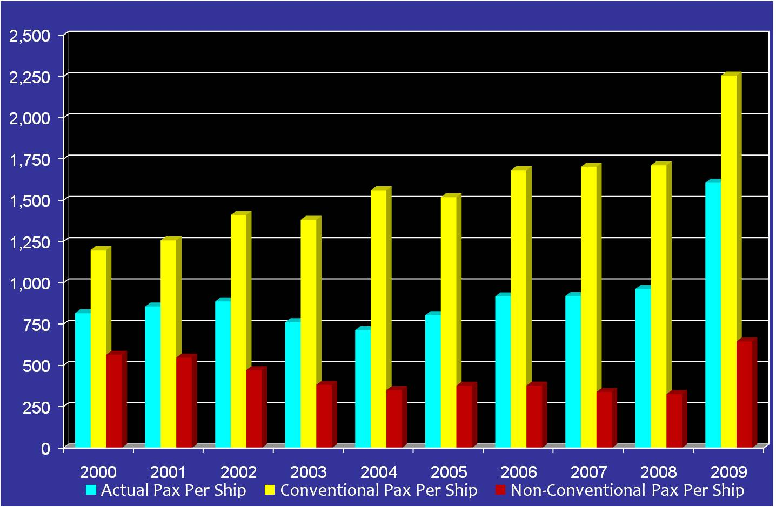

Cruise Port Competitors. To a large degree, Port Everglades and the Port of Miami are in a unique position within the hierarchy of homeports in that they are historically positioned to provide the primary homeport opportunities for the industry. To a great degree, the cruise industry is a product of South Florida and this is reflected in the ability of these primary ports to meet the needs of the local industry with headquarters and administrative offices literally in and across the street from these major ports and terminals.

In addition, cruise vessels deployed by the major lines to the region can be well supported by the ability of the South Florida tourism infrastructure to lure visitors from around the world, while also providing a large number of local cruise consumers to the marketplace. Growth of the industry away from these two primary ports has been generated by the supply of ships and requirements of the cruise industry to increase its overall consumer market.

Finally, both ports are restricted in terms of the total berth and terminal capacity that can be offered to the cruise industry. This is driven both by the physical limitations of the ports themselves and by their financial ability to continue building facilities to meet the increasing demands of the cruise industry.
Thus, Port Everglades’ primary cruise port competitors are those ports geographically situated within Florida which have the ability to provide the cruise line industry with additional berths and other facilities accommodating passenger capacity growth. These ports include:
- Port of Miami. Situated less than 30 miles from Port Everglades, the Port of Miami is a land-constrained port that offers the cruise line industry some of the newest terminal facilities and access to key consumer markets through air and drive markets. Growth of the Port of Miami is limited, however, unless accommodations are made outside of the present port template. Throughput has remained relatively flat over the past five years.
- Port Canaveral. In general, Port Canaveral is similar to Port Everglades in its ability to provide for both daily and non-conventional and multi-day cruise offerings. Its strength lies in its accessibility to the Orlando area and large consumer market. Disney Cruise Line has done much to bolster the fortunes of Port Canaveral through the development of a cruise terminal facility. Growth has been significant for the port over the past five years. There are, however, limitations to Canaveral’s development due to its geographic location and ability to offer Western Caribbean sailings within an 8-day program. Most of its traffic is concentrated on the Bahamas and Eastern Caribbean.
- Port of Tampa. While also having the ability to tap into the Orlando market, the Port of Tampa has less name-brand recognition than other ports in Florida. Tampa has the physical height restriction of the Sunshine Skyway Bridge (approximately 185 feet), limiting the size of cruise vessels that can access Tampa Bay and the port.
Today, like most other ports, Port Everglades competes against more ports for cruise traffic than ever before due to the continuing maturity of the cruise industry in North American homeport deployment and the worldwide introduction of new cruise programs. Secondary competitors of Port Everglades include:
- New York City. The Port of New York and New Jersey offers homeport sailings year-round to the Caribbean region from a lucrative Northeast cruise consumer market.
- San Juan, Puerto Rico. Geographically well positioned to offer the entirety of the Caribbean, the port is challenged by airlift limitations and ticket cost as well as ongoing labor issues.
- Port of New Orleans. This port offers service primarily to the Western Caribbean. It is limited by a long pilotage transit and the ability to accommodate the largest cruise vessels.
- Port of Jacksonville. Relatively new to the cruise industry, Jacksonville offers a limited direct-drive market from Atlanta and the Southeast. Other limitations are its ability to accept large vessels and offer itinerary patterns deep into the Caribbean on sailings of less than 8 days.
- Port of Palm Beach (one-day sailings). Palm Beach is severely limited to accepting only small cruise vessels because of its channel entrance restrictions. It has, however, provided a good platform for the Palm Beach Princess, offering gaming/entertainment cruises. It is in this capacity that the Port of Palm Beach competes with Port Everglades.
- Ports of Galveston/Houston. These ports offer access to Midwest consumer markets and provide limited direct competition for Port Everglades over the mid- to long-term.
Figure 2.6-13 illustrates passenger throughput for Port Everglades’ primary cruise port competitor – the Port of Miami -- as these two ports consistently compete for additional traffic in this region. The Port of Miami has continued to increase capacity at a rate of 1.29 percent annually, while Port Everglades has also seen solid growth at 1.01 percent annually.

Figure 2.6-13

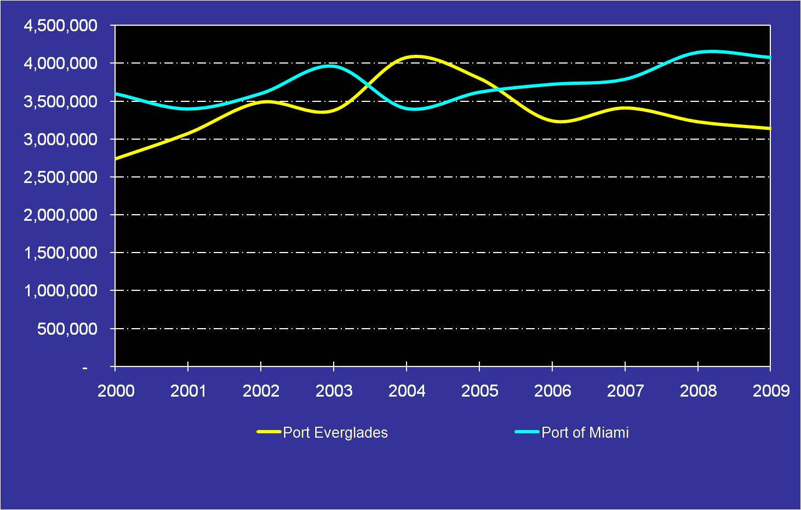
Port Everglades / Port of Miami Passenger Throughput, 2000 - 2009

Source: Cruise Industry Annual, and B&A, 2009

Several factors influencing the growth of regional cruise traffic and affecting all of the primary ports are as follows:
- Homeland market. Homeports along the Atlantic and Gulf Coasts have opened key drive markets for cruise lines.
- Key demographic target markets. Northeast and Southeast regions provide an overall disproportionate volume of cruisers in North America.
- Eight-day cruise product. The ability of new cruise vessels to reach the Caribbean and Bahamas has changed deployments, primarily from the Northeast region.
- Seasonality of US East Coast region. Not until 2003 were northern US coastal ports considered for year-round cruising. Today all of the major lines operate itineraries to the Caribbean from this region.
- Airlift. Airlift, once an important factor, has essentially been taken out of the mix with deployment offers. The movement of cruise vessels to a variety of homeports in North America has limited the need for extended flights and increased potential drive markets.
- Vessel size / capacity. Infrastructure and the ability to service larger cruise vessels are critical factors for the long-term success of any of the competitor ports in the region, including Port Everglades.

2.6.4 Projection of Port Everglades’ Cruise Growth Opportunities and Berth Demand.

Section Summary. This section examines the potential future cruise passenger and vessel throughput for Port Everglades, based on the Consultant Team’s current knowledge of the region overall and historical data collected during the assessment process. From the assessment of the total berths required to support cruise operations, a total of necessary accommodations for Port Everglades can be established over the long-term (through 2029). This assessment is summarized below:
- Based on the daily and non-conventional cruise projections, this cruise sector drops from approximately 508,000 revenue passengers in FY 2009 to 321,000 passengers in 2029. This is a drop of 1.84 percent annually. Cruise vessel calls fall from 394 to 199 calls in 2029.
- For multi-day conventional cruises, under Scenario 1 (Trend Regression Analysis), the average annual growth of Port Everglades’ multi-day cruise market is 0.64 percent over the planning period (approximately 12.9 percent over 20 years). Thus, revenue passenger totals climb from 2.6 million in 2009 to 2.9 million in 2029. Cruise vessel calls decline from 583 in 2009 to 489 in 2029.
- Under multi-day cruise Scenario 2 (Port Everglades / Port of Miami Traffic Split), the average annual growth of Port Everglade’s multi-day cruise market ranges from 2.76 percent (low) to 6.56 percent (high) annually. Under the composite approach (of the three low, mid, and high levels under Scenario 2), revenue passenger totals climbs to 3.9 million in 2014 and more than 5.5 million in 2029. Cruise vessel calls climb to 804 in 2014 and 913 in 2029 with vessel capacities growing from 2,256 per ship in 2009 to 3,039 passengers per ship in 2029.
- Multi-day cruise Scenario 3 (Cruise Market Capture Projection Analysis) shows cruise passenger throughput ranging from 2.5 million (low) and 3.2 million (high) in 2014 and 2.9 million (low) to 5.5 million (high) in 2029. Cruise calls range from 490 (low) to 907 (high) in 2029, based on the projection models. Growth rates for the low, mid, and high levels presented range from .66 percent to 5.48 percent annually.
- Multi-day cruise Scenario 4 (Scenario-Based Projection Analysis - Cruise Vessel Deployments) shows cruise passenger throughput expanding to 3.9 million in 2014 and 4.1 million in 2029. Cruise calls decline from 814 in 2014 to 682 in 2029. Based upon the projection model, the growth rate for Scenario 4 is 2.88 percent annually.
- The composite approach (the most likely scenario for a combined throughput of multi-day and non-conventional sailings) grows from 3.1 million passengers in 2009 to 4.0 million in 2014, 4.4 million in 2019, and 5.1 million in 2029. Cruise calls go from 977 in 2009 to 996 in 2029. Cruise passenger capacity per vessel under this combined Composite Projection Scenario moves from 1,607 passengers to 2,592 passengers in 2029.
- Berth demand for the most likely Composite Projection Scenario requires 10 to 11 berths, with approximately 8 of those having an approximately 1,100-foot LOA to meet the design vessel specifications.

Preliminary Projection Qualifications. Qualifications for the Port Everglades’ growth scenarios offered in this section, based on the projection models, include the following:
- Despite recent (and potential future) major upheavals in world affairs, projections anticipate that the cruise industry will continue to follow fundamental positive trends.
- The forecast methods and various assumptions inherent in each incorporate the Consultant Team’s best interpretation of demand and supply conditions in the marketplace as of the date of this assessment
- Projections were developed for cruise passenger throughput first, with anticipated vessel arrivals extrapolated from this total, using observed average vessel sizes for Port Everglades.
- Tariff and general destination service levels are assumed to remain constant with those presently observed.
From the information assembled, it is believed these general scenarios provide a solid growth projection model. Testing indicates that the scenarios presented are within a reasonable range for the region and present a conservative future growth projection for Port Everglades. The projections are, however, unconstrained and do not consider the potential berth capacity, peaking utilization, or other limiting factors of Port Everglades as well as downstream port facilities within the Caribbean or other future cruise patterns that may be served from Port Everglades. Finally, daily and non-conventional sailings are separated from multi-day as part of the projection models.

Historical Traffic and Passenger Ship Projections. Presented below is the historical traffic of Port Everglades over the past ten-year period to provide the general platform on which to build the assembled projection scenarios (see Figure 2.6-14). Additionally, the annual per-passenger vessel growth over the 20-year planning period has been estimated for both multi-day and daily and non-conventional cruise vessels calling at Port Everglades.

Figure 2.6-14

Historical Traffic for Port Everglades, 2000 - 2009

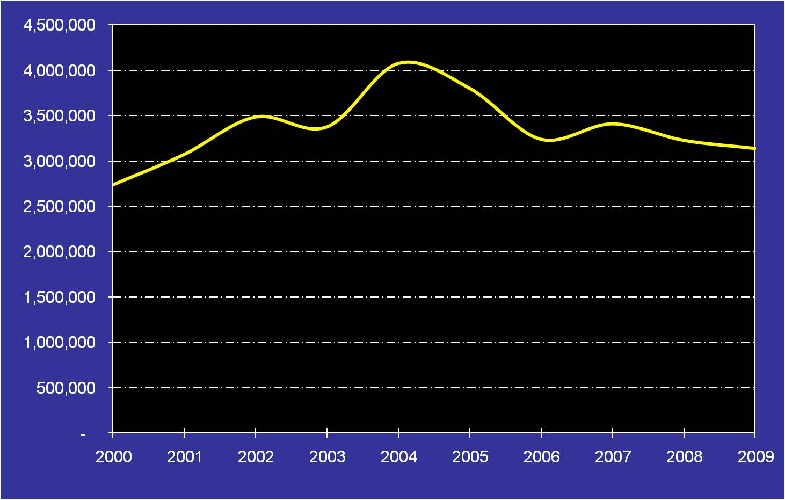
Source: B&A, 2009

Over the past five years, significant growth has occurred in the passenger-carrying capacity of cruise vessels at Port Everglades. The annual growth rate over this period is extremely high and it is not anticipated that this rate could be sustained for a much longer period. Based on the Consultant Team’s knowledge of the industry, new-build trends, and current and planned vessel deployments to the Caribbean region, a more conservative average annual growth rate of 1.5 percent over the 20-year planning period has been assumed. This represents a multi-day cruise vessel capacity increase from 2,256 passengers per ship in 2009 to approximately 3,039 passengers per ship in 2029 (see Figure 2.6-15).
Figure 2.6-15

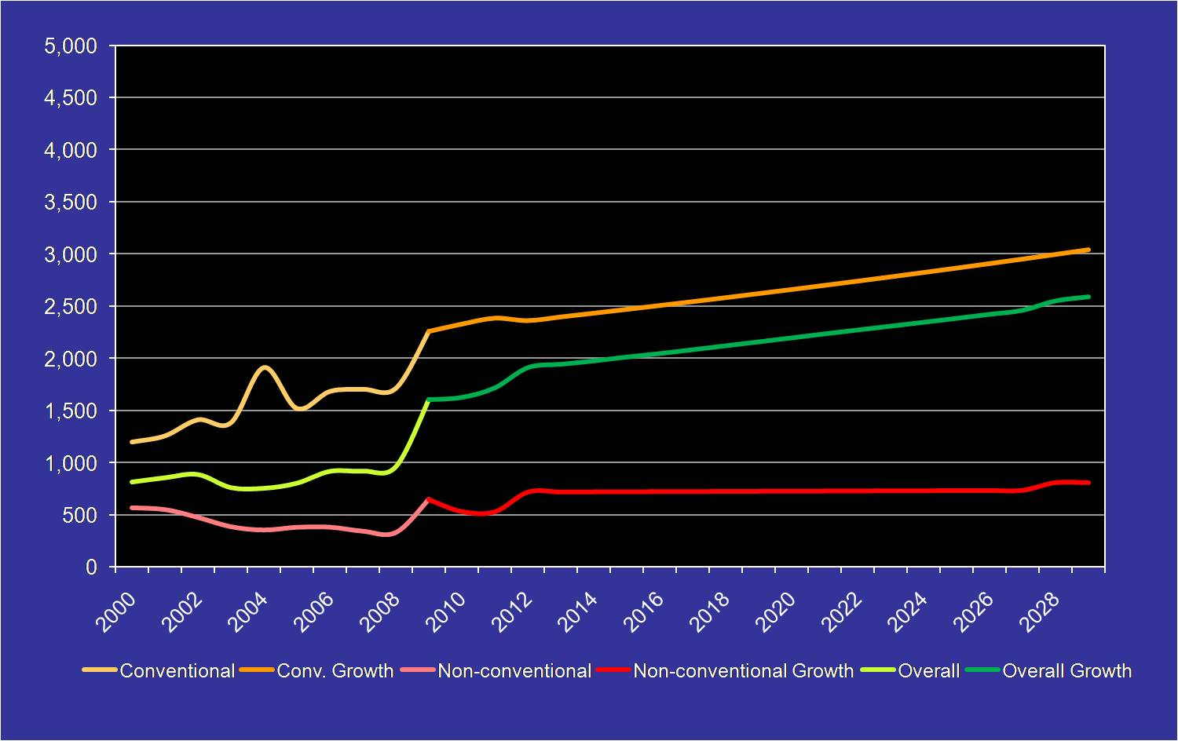
Passenger per Vessel Projections, 2000 - 2029

Source: B&A, 2009

For daily and non-conventional capacity projections, a no-growth scenario has been assigned to the vessels under the baseline scenario. Based on a trend regression assessment, a vessel capacity size of 645 passengers has been allocated over the planning period to 2029. Additionally, it is possible that the Discovery cruise vessel, based upon its age, may not operate into the mid-term. To address this vessel move and the Bahamas Celebration as the sole non-conventional vessel, this second scenario then falls to approximately 900 passengers per sailing over the period.
Daily and Non-Conventional Cruise Projections. From information assembled as part of the planning process, two projection approaches were used for daily and non-conventional cruise operations; these reflect the most likely growth assumptions for Port Everglades over the 20-year planning period. Scenario 1 provides for the continuation of this cruise sector over the long-term. Based upon past trends, however, the level of growth continues to fall. Scenario 2 provides for the Discovery cruise vessel’s departing the market in the mid-term, given the vessel’s age and lack of market pull due to deployment of multi-day cruise vessels at reduced pricing and the pull of the newly renovated Bahamas Celebration.
Under these scenarios, the projection model includes dailies (Discovery) and non-conventional (Bahamas Celebration) cruise operations. A general trend / regression analysis was used based on past growth in each cruise sector. This follows the Port’s historic trends within the daily and non-conventional cruise sectors over the past five years. As illustrated:
- Vessel call projections are based on a no-growth scenario. It is assumed the Bahamas Celebration will afterward be categorized as a conventional cruise vessel and reported accordingly.
- Discovery Cruises relies on local Bahamas and South Florida markets, cargo operations, and low overhead to be a viable operation at Port Everglades. This is a niche market.
- Bahamas Celebration is a new venture and a unique gaming / entertainment concept that is vulnerable to outside gaming regulation and entertainment competitive influences. It appears, however, that a reasonable business model has been installed to differentiate this product and market to several overlapping consumer demographics in the immediate area. The venture has shown a strong start-up operation.
- Discovery Cruises will, at some point, need to upgrade the existing vessel or purchase a new vessel within the projection period. Providing a business model that can sustain these large expenses will be difficult to achieve, given the potential for a declining market. The current economic conditions do, however, provide good leverage for this cruise type.
- To a great degree, Port Everglades has the ability to support this small niche market with dedicated facilities and incentives. This is, however, a difficult choice, given the pressures asserted by multi-day cruise operations and other outside tourism influences.
From the two daily and non-conventional Cruise Projection Scenarios, a Composite Projection was established: this cruise sector drops from approximately 508,000 revenue passengers in 2009 to 321,000 passengers in 2029 (see Figure 2.6-16). This is a drop of 1.84 percent annually. Cruise vessel calls fall from 394 in 2009 to 199 calls in 2029. This is a drop of 2.70 percent annually (see Figure 2.6-17).

Figure 2.6-16

Daily/Non-Conventional Revenue Passenger Projections (Most Likely Scenario)
Source: B&A, 2009

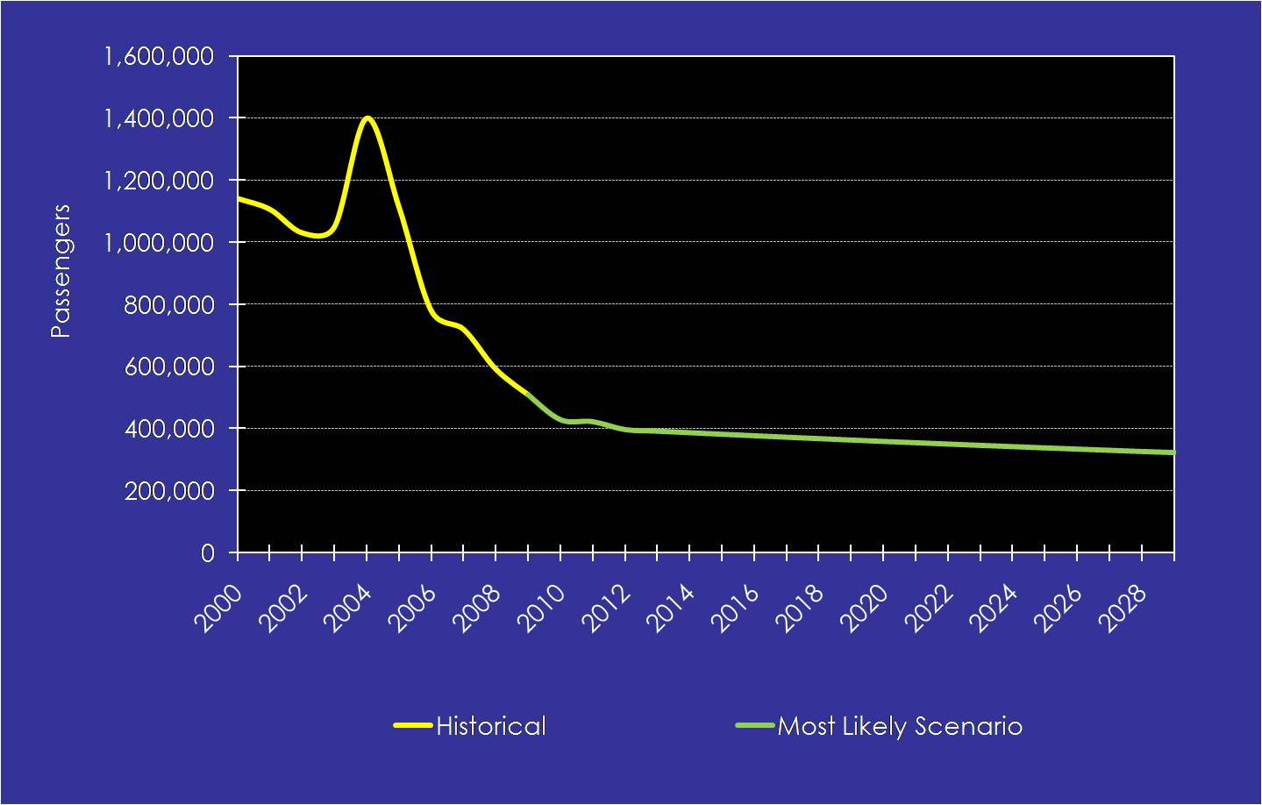
Figure 2.6-17

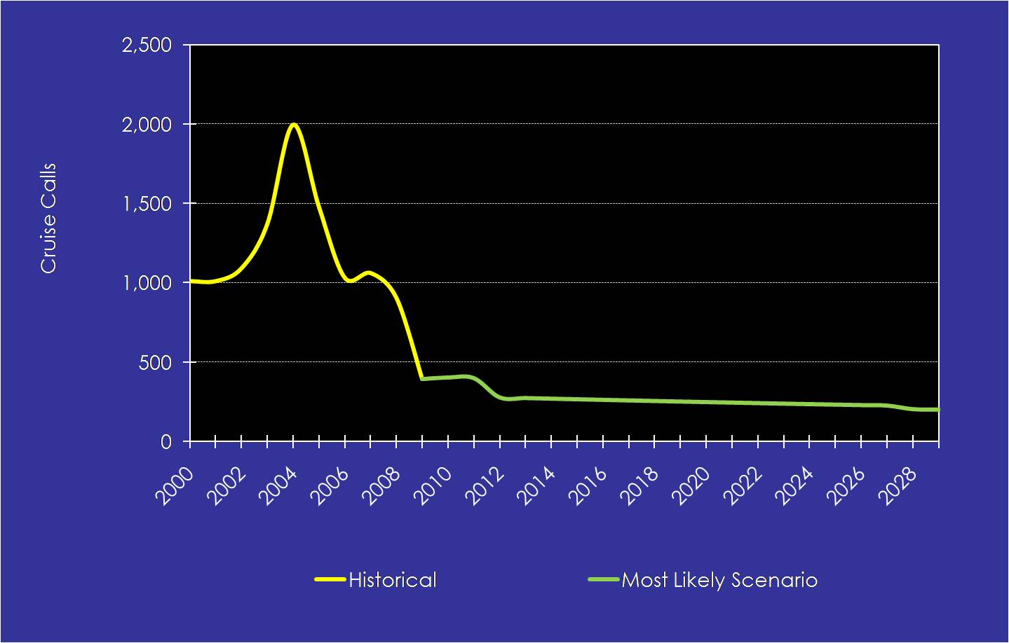
Daily / Non-conventional Cruise Call Projections (Most Likely Scenario)

Source: B&A, 2009

Multi-day Cruise Projections. From information assembled as part of the planning process, four scenarios were developed for multi-day cruise operations. These scenarios, which reflect the most likely assumptions for Port Everglades’ growth over the 20-year planning period, are discussed below.

Scenario 1 Projection – Trend Regression Analysis (Baseline). The following methodology was used to prepare a trend regression analysis projection for Port Everglades:
- The analysis was used, based on past growth in each of the primary cruise sectors associated with the Port’s cruise operations, as discussed in Section 2.6.2.
- The analysis follows the Port’s growth trends over the past five years.
- Vessel call projections are based on current vessel capacity growth, both in the region and for Port Everglades. As noted earlier, this dramatic increase is unlikely to continue. Thus, this trend will fall from between 1.5 to 2 percent over the 20-year planning period. To maintain consistency, 1.5 percent capacity growth overall has been used to project vessel capacity under all scenarios.
As presented, under Scenario 1, the average annual growth of Port Everglade’s multi-day cruise market is 0.64 percent over the planning period (approximately 12.9 percent over 20 years). Thus, revenue passenger totals climb from 2.6 million in 2009 to just over 2.7 million in 2014 and then to more than 2.9 million in 2029 (see Figure 2.6-18). Cruise vessel calls fall from 583 in 2009 to 560 in 2014 and 489 in 2029.

Figure 2.6-18

Scenario 1 –Trend Regression Analysis Passengers, 2009 - 2029

Source: B&A, 2009

Scenario 2 Projection – Port Everglades / Port of Miami Traffic Split. Scenario 2 contemplates that Port Everglades and the Port of Miami have had a historical splitting of traffic in the region. The average split over the past five years is 39.07 percent for Port Everglades as shown in Figure 2.6-19.

Figure 2.6-19

Port Everglades’ Historic Share of Regional Traffic, 2000 - 2009

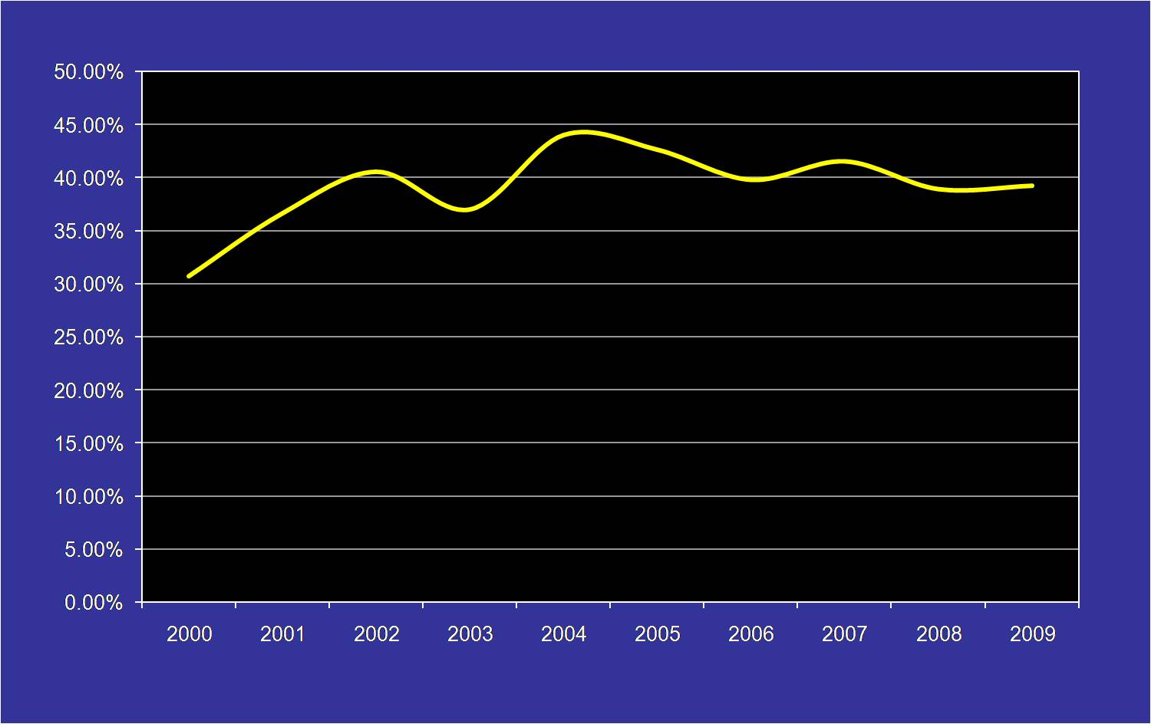
Source: B&A, 2009

Figure 2.6-20 shows the growth of the major regional Caribbean and Bahamas cruise sectors that impact Port Everglades, which ranges from 1.16 percent to 5.34 percent annually over the period. The projection has considered all of the spheres of influence on the Port.

Figure 2.6-20

Regions of Importance to Port Everglades, Passengers

Source: B&A, 2009

Based upon the traffic split for the above regions, Figure 2.6-21 provides the projected growth for the low to high alternatives in Scenario 2. As presented, the average annual growth of the Port’s multi-day cruise market ranges from 2.76 percent (low) to 6.56 percent (high) annually.

Figure 2.6-21

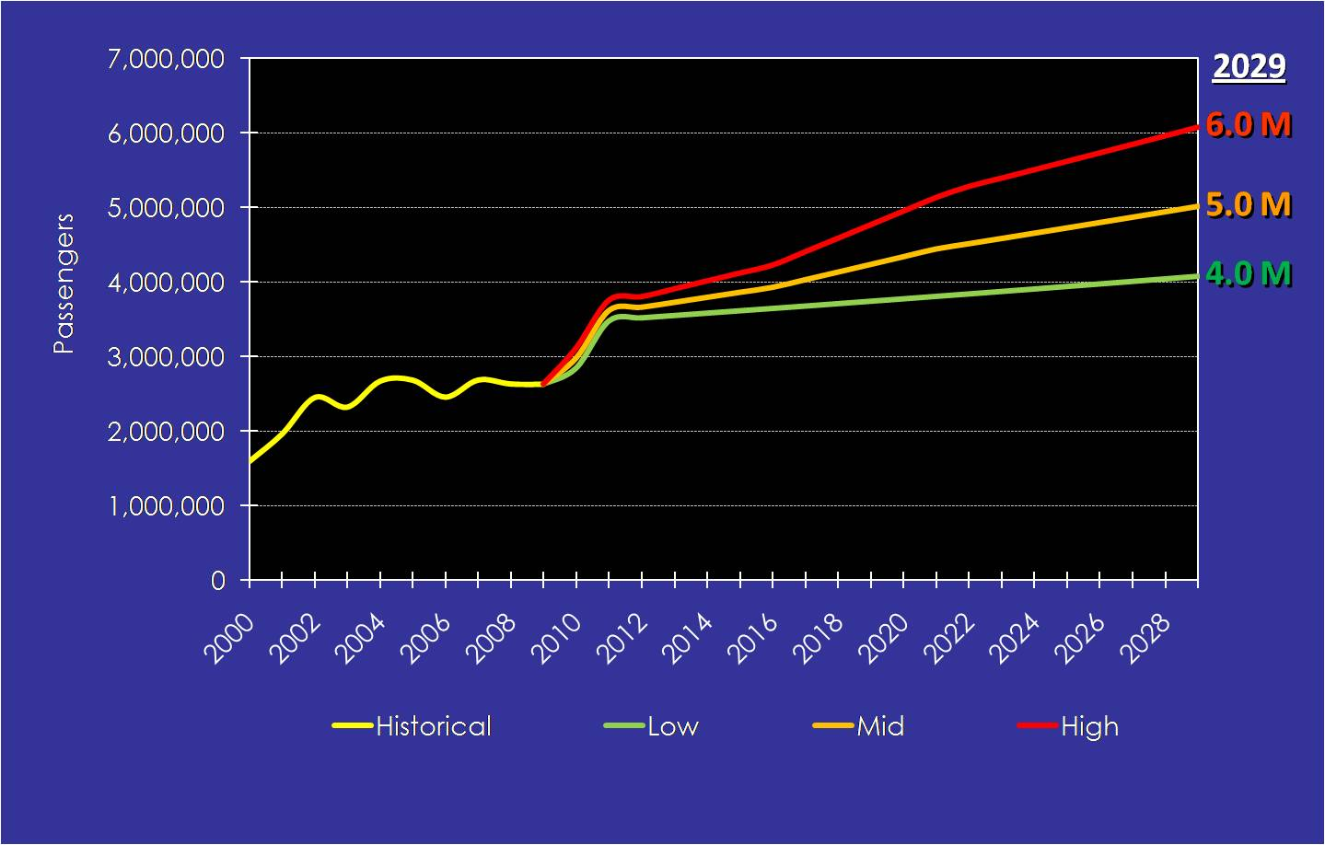
Scenario 2 - Multi-Day Traffic Split Projections, 2009 - 2029

Source: B&A, 2009

Thus, revenue passenger totals climb from 2.6 million in 2009 to 3.7 million in 2014 and 5.0 million in 2029 under the mid-point model. Cruise vessel calls climb from 583 in 2009 to 783 in 2015 and 826 in 2029.

Under the composite approach (of the three low, mid, and high levels under Scenario 2), revenue passenger totals climbs to 3.9 million in 2014 and more than 5.5 million in 2029.

Scenario 3 – Cruise Market Capture Projection Analysis. Under this scenario, it is anticipated that Port Everglades will capture a percentage of the overall regional marketplace, based upon its past successes in this area. Figure 2.6-22 provides the baseline for this Capture Scenario. As presented, Port Everglades’ capture ranges from between 19.2 percent to 21.2 percent under the three approaches (low to high). Over the past five years, the average has been 21.2 percent, but is now 20.9 percent in 2009.

Figure 2.6-22

Regional Market Capture, 2000 - 2009

Source: B&A, 2009
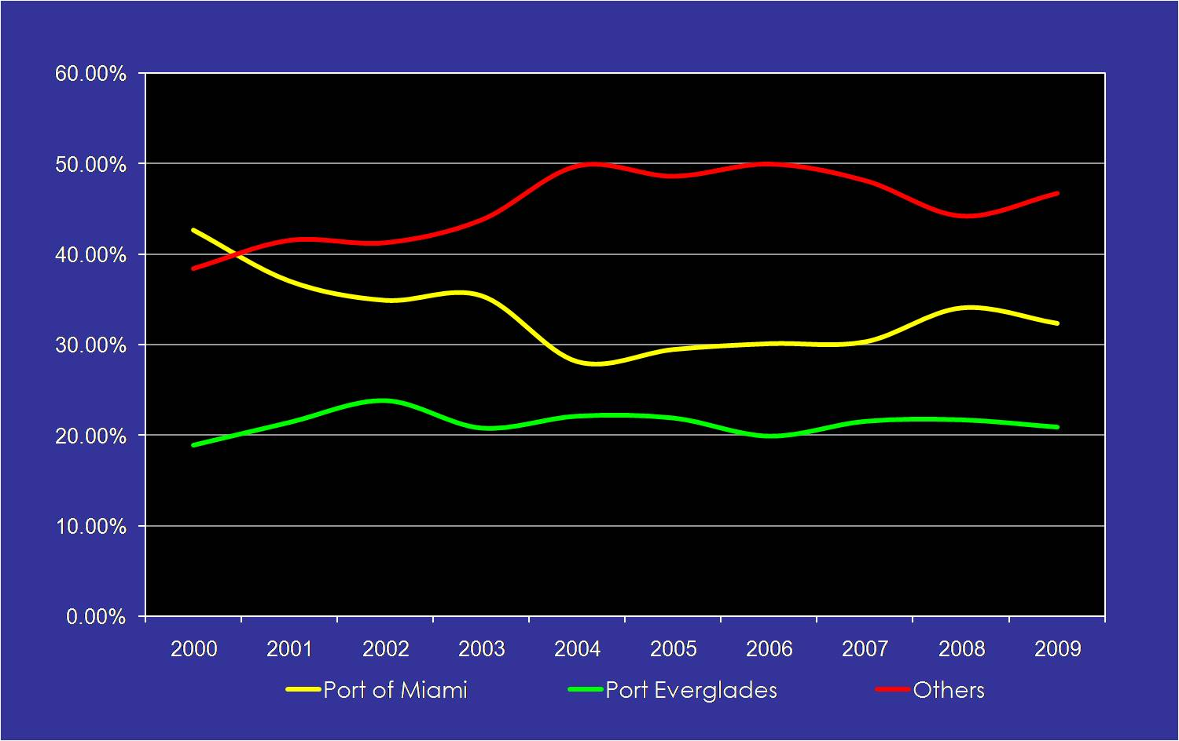
Under this Scenario, cruise passenger throughput ranges from 2.5 million (low) and 3.2 million (high) passengers by 2014, 2.6 million (low) and 4.0 million (high) in 2019, and 2.9 million (low) to 5.5 million (high) in 2029. Cruise calls vary from 490 (low) to 907 (high) in 2029, based on the projection models.
Growth rates for the scenarios presented range from 0.66 percent to 5.48 percent annually (see Figure 2.6-23). The Composite Projection for Scenario 3 reflects the most likely target of 4.8 million passengers by 2029 with 793 cruise calls.

Figure 2.6-23

Scenario 3 Market Capture Revenue Passengers, 2009 - 2029

Source: B&A, 2009
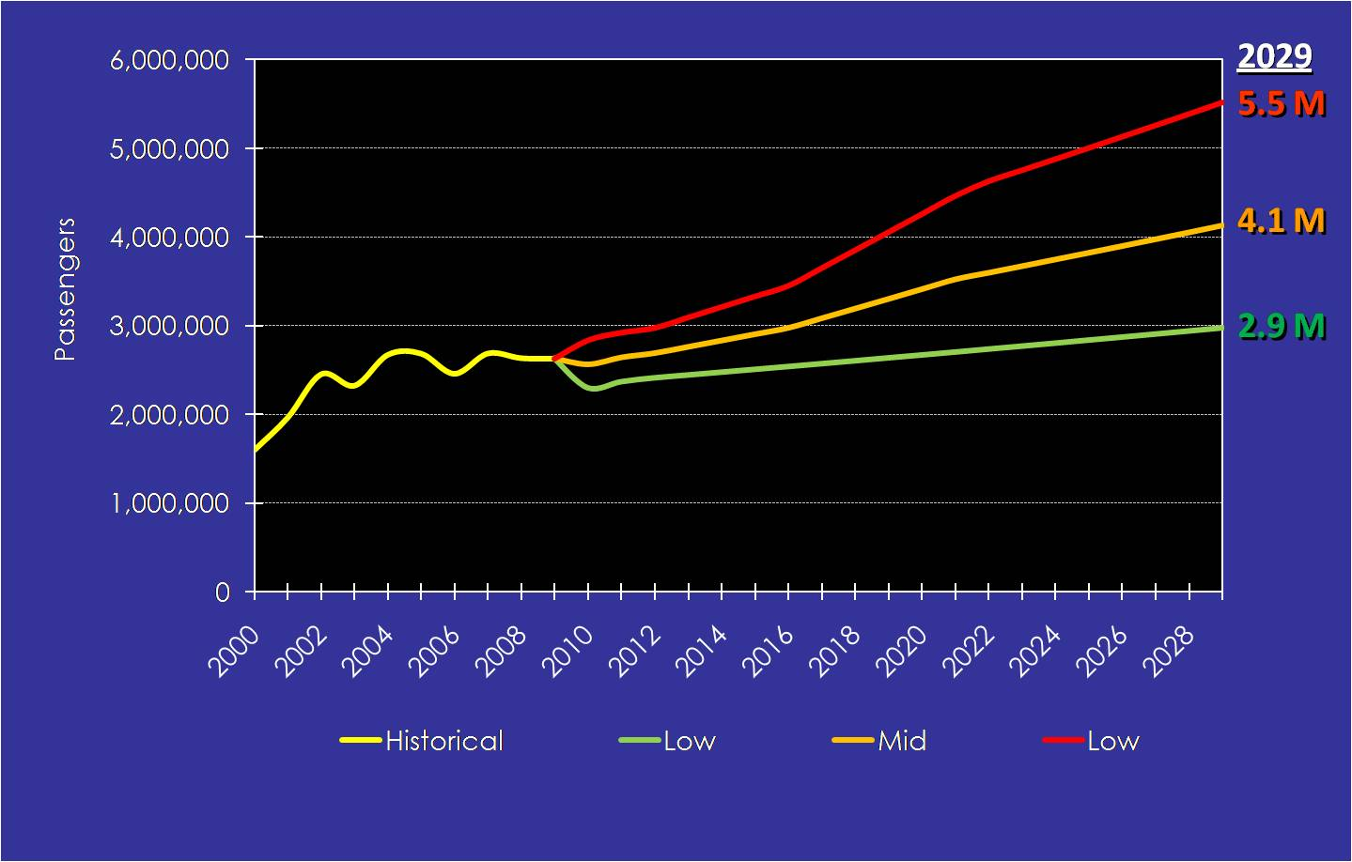

Scenario 4 – Scenario-Based Projection Analysis (Cruise Vessel Deployments). Under Scenario 4, cruise lines, finding the right incentives, pricing points, and products to put into place in the region, allow for slightly greater deployment levels beyond those occurring presently. As with all projections, after the 5-year window, it is difficult to forecast deployments due to potential market modifications and geo-political events worldwide. To the extent possible, future deployment additions / replacements over the projection range have been identified. Assumptions include:
- Mainly replacements for seasonal smaller vessel deployments in favor of larger mega- ships.
- Deployment of Oasis of the Seas and Allure of the Seas to Port Everglades.
- Additional 5-, 5- 4-day sailings in the region anticipated to boost Port Everglades’ capacity.
- Possible addition of a new brand to the Port Everglades’ mix in the short- to mid-term.
The anticipated midpoint of Scenario 3 was used as the baseline for Scenario 4, with the additional vessels included, as shown above. Under Scenario 4, cruise passenger throughput expands to 3.9 million passengers by 2014 and reaches 4.1 thereafter (see Figure 2.6-24). Cruise calls number 682 in 2029, based on the projection models

Figure 2.6-24

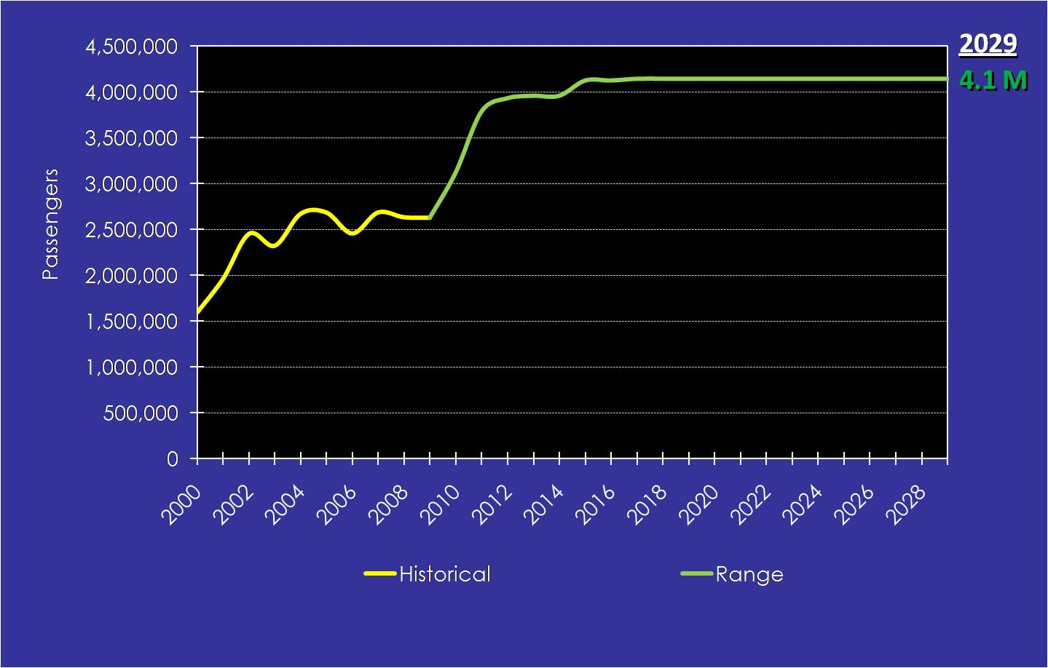
Scenario 4 Scenario-Based Projections, 2009 - 2029

Source: B&A, 2009
Overall Projection Ranges. Figure 2.6-25 illustrates the overall projection ranges when both the multi-day and daily and non-conventional revenue passenger projections are included. As shown, the most likely combined Composite Projection provides for 5.1 million revenue passengers in 2029. Overall, continued, albeit slower-paced, growth is envisioned for the Port over the mid- to long-term. Much of the growth opportunities will depend on addressing the infrastructure requirements of future cruise vessels entering the Caribbean region.

Figure 2.6-25

Most Likely Revenue Passenger Projection

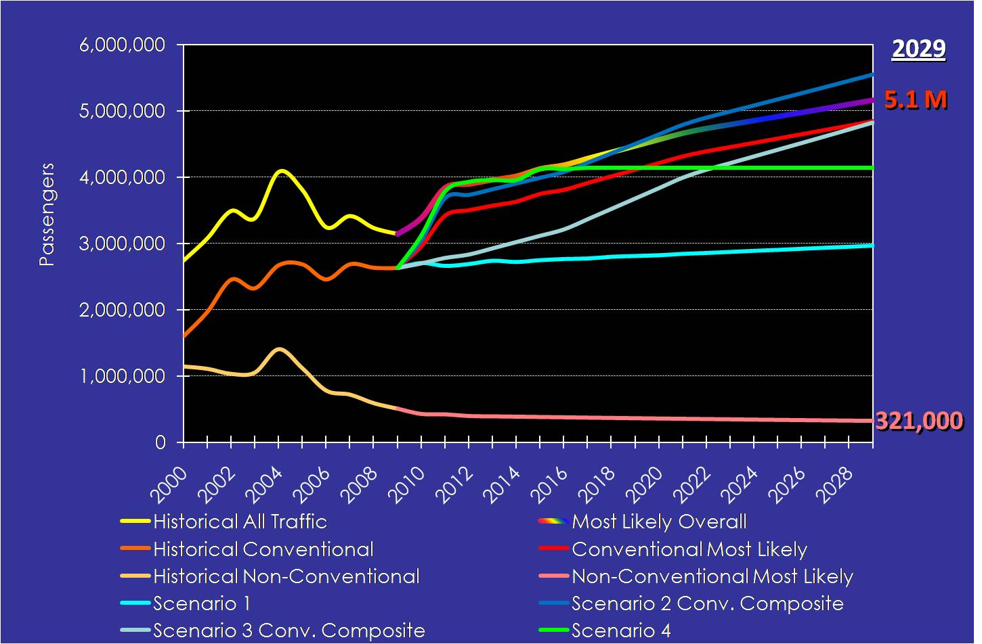
Source: B&A, 2009

Table E-1, entitled Projection Range of Overall Port Everglades Cruise Passenger and Call Throughput, 2009-2029, in Appendix E, shows the complete projection range of cruise passengers and calls at Port Everglades over the planning period. This table includes all scenarios and composite projection analyses. For the most likely scenarios for conventional and non-conventional cruises, the present number of berths is used, which does not correspond directly to the berth demand assessment completed in Table E-2. Additionally, Berth 4 is currently used by both conventional and non-conventional vessels.
Port Everglades Traffic Analysis Summary. Part of the process in accurately identifying long-term berth demand is to develop an understanding of the traffic patterns to the port or facilities in question. In the case of Port Everglades, a defined seasonal, monthly, and daily traffic pattern emerges through analyzing the historical traffic data. The drivers associated with the Port Everglades traffic patterns include the seasonality of the regional cruise market sector, profitability, and competition from cruise regions throughout the year, based on the same factors. Berth demand factors fall into five categories:
- Total volume. Volume depends on the amount of cruise traffic at the Port and the potential for future traffic within the peak seasons, months, or days.
- Size of vessel. Larger vessels within the market over time will likely decrease the total volume of vessel calls, while increasing passenger throughput. Additionally, the LOA of the vessel is an important component in assessing the size of future infrastructure needed to support cruise operations.
- Seasonality. For Port Everglades, the bulk of traffic is set during the peak Caribbean winter months of November through April due to weather conditions, but also because of the attainable profits seen in other summer markets such as Alaska and the Mediterranean.
- Length of cruise. Cruise length directly affects the peak days in which a port experiences the majority of its cruise calls. For Port Everglades, the majority of cruises are less than 8 days with future deployments likely falling into 5-, 5-, 4-day patterns. These patterns drive the peaking of weekend days at the Port. Additionally, Port Everglades is also favored for longer sailings that further complicate the overall mix and berth scenarios.
- Daily fluctuations. Port Everglades provides numerous types of sailings from daily and non-conventional to multi-day. Within this range, particularly during the peak winter months, there will be days when more vessels converge on the Port – peak days -- which in some cases drive future development to support this influence.
Within this context, the traffic patterns at Port Everglades were evaluated and the following factors identified:
- Seasonal and monthly traffic patterns are primarily driven by the winter Caribbean season, with a focus on November through April. A secondary factor is the shoulder season redeployment of vessels from the European cruise patterns to those in North America, primarily the Caribbean region in October and May. This redeployment, however, appears to be shrinking each year as the Mediterranean season is extended. Alaska deployments also drive cruise calls to Port Everglades, as vessels move from one region to the next.
- Port Everglades is a homeport with a distinct seasonality for cruise tourism. To a great degree the success of Port Everglades is very much linked to the Caribbean region overall.
- January, at 16 percent of traffic, was the highest month in FY 2009.
- In FY 2009, Saturday is the peak day with 31.4 percent of traffic.
Figure 2.6-26 illustrates the historical calls for both daily and non-conventional and multi-day cruises over the past five years. As shown, both show decreases since FY 2004. Decreasing calls for the multi-day sector, however, are mainly due to the replacement of smaller ships with larger vessels over the past two years. Also as shown, this trend has leveled off since 2006. The decrease in the daily and non-conventional sector is primarily due to the reduction of this traffic at Port Everglades over this period.

Figure 2-6-26

Cruise Vessel Calls, 2000 - 2029

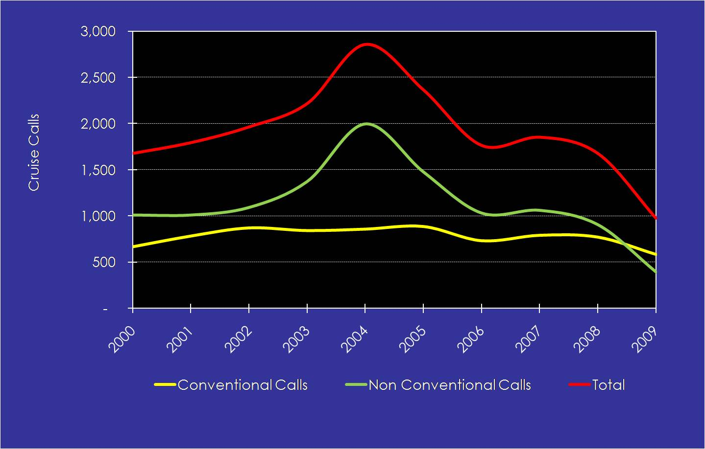
Source: B&A, 2009

In the same regard, Figure 2.6-27 shows that the cruise passenger capacity of the multi-day conventional vessels has increased over the period, while the daily and non-conventional sailing capacities have also risen, mainly due to the retirement of smaller vessels and the introduction of the Bahamas Celebration in 2009. The growth of vessel capacity is a major driver for Port Everglades in terms of berth and upland terminal requirements.

Figure 2.6-27

Passengers per Cruise Vessel

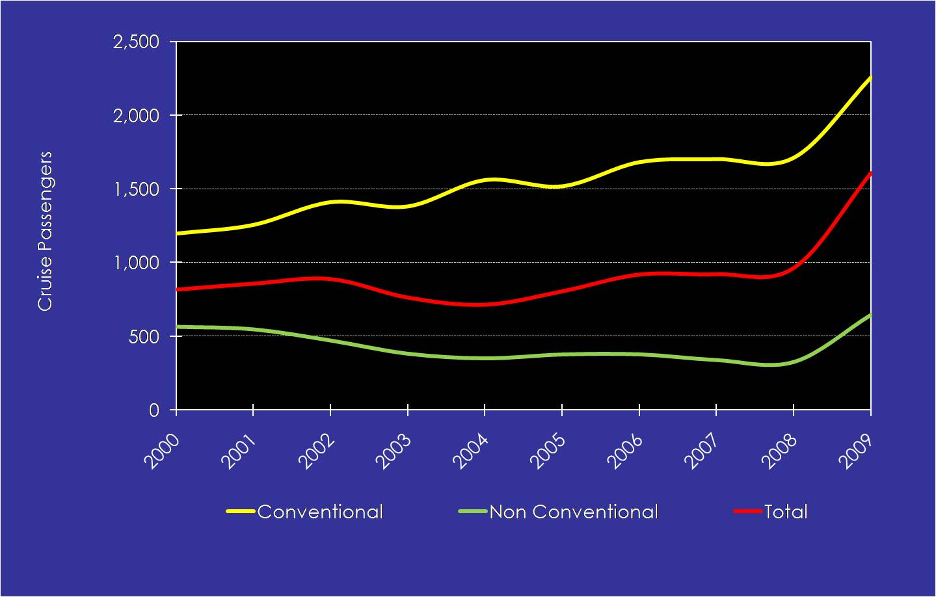
Source: B&A, 2009

Based on the most likely revenue passenger projections, the total number of vessel calls over the period was generated using a conservative annual growth rate of 1.5 percent over the entire planning period. While growth in terms of capacity has been impressive over the past several years, this area cannot continue to grow at such a rate. Thus, knowledge of the region, new-build plans, and deliveries into the region has dictated the use of the 1.5 percent growth average.
Figure 2.6-28 illustrates the total number of vessel calls under each of the most likely scenarios over the planning period.

Figure 2.6-28

Combined Vessel Call Projections, 2009 - 2029

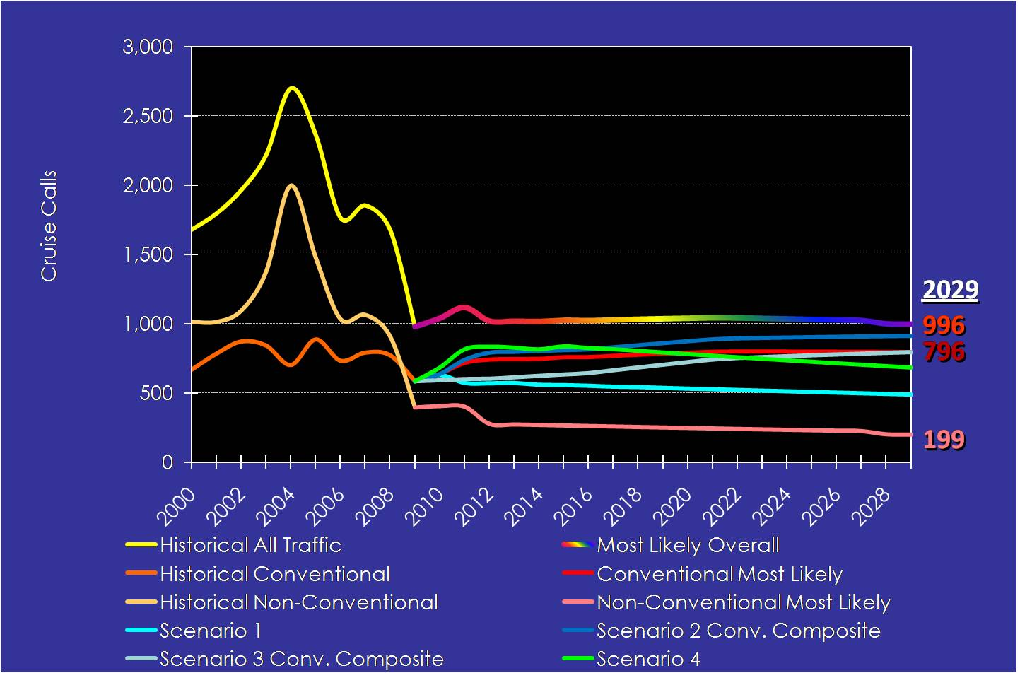
Source: B&A, 2009

These projection scenarios are also shown in Table E-1, in Appendix E.
Monthly Traffic Analysis and Seasonality. Figure 2.6-29 provides a snapshot of the monthly passenger traffic at Port Everglades from 2005 through 2009. As illustrated, there has been a set pattern of cruise seasonality directly related to the Caribbean winter cruise season. Typically, the peak months for Port Everglades are October through April, with conventional traffic falling thereafter during the summer months. Limited summer cruise activities occur from June through September.
Over the long-term, it is believed this pattern will track closely to the 5-year average and not continue to expand, primarily due to market influences into the summer months. Seasonal cruise activities can also be attributed to outside influences, primarily Europe, Alaska, and Mediterranean market trends.

Figure 2.6-29

Monthly Passenger Traffic, 2005 - 2009
Source: B&A, 2009
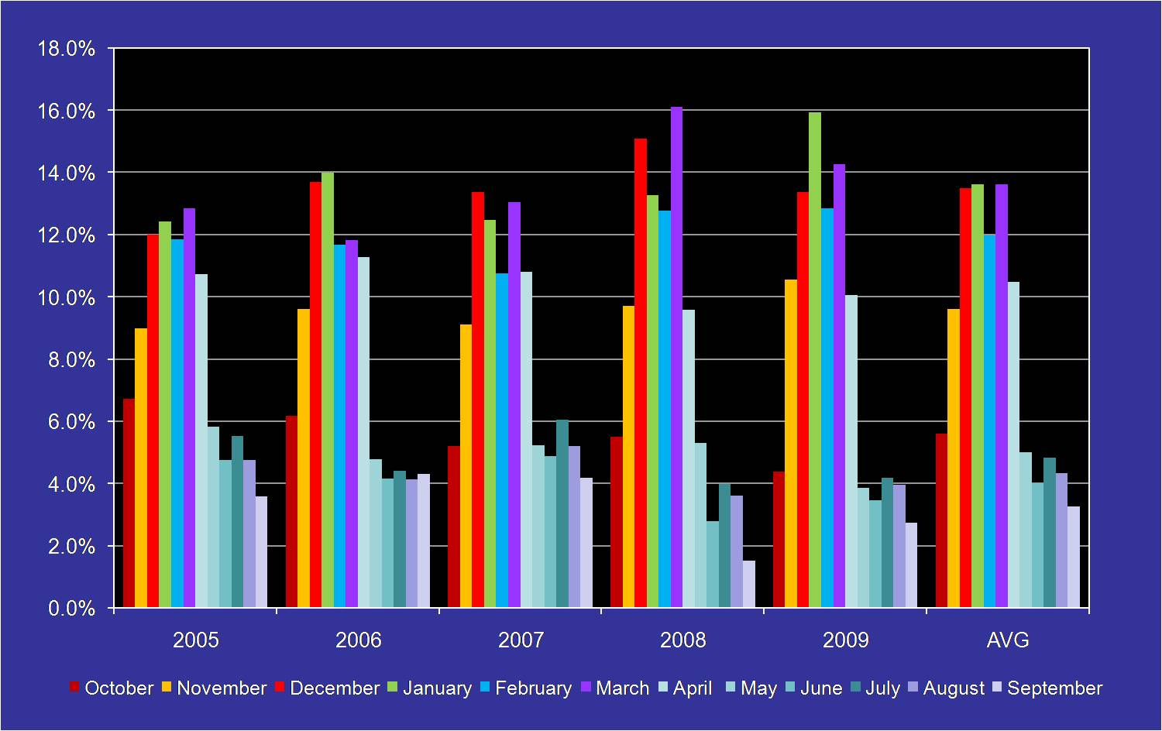

Figure 2.6-30 illustrates the actual monthly calls at Port Everglades, based on the most likely outcome projection analysis. Traffic splits per month are shown with the peak months being December through March into the long-term. As it is extremely difficult to project past this period, it is important to establish a solid foundation for growth over the next 5 years in terms of infrastructure development to meet the future capacity requirements
.

Figure 2.6-30

Monthly Cruise Call Traffic, 2015, 2020, 2025, 2029

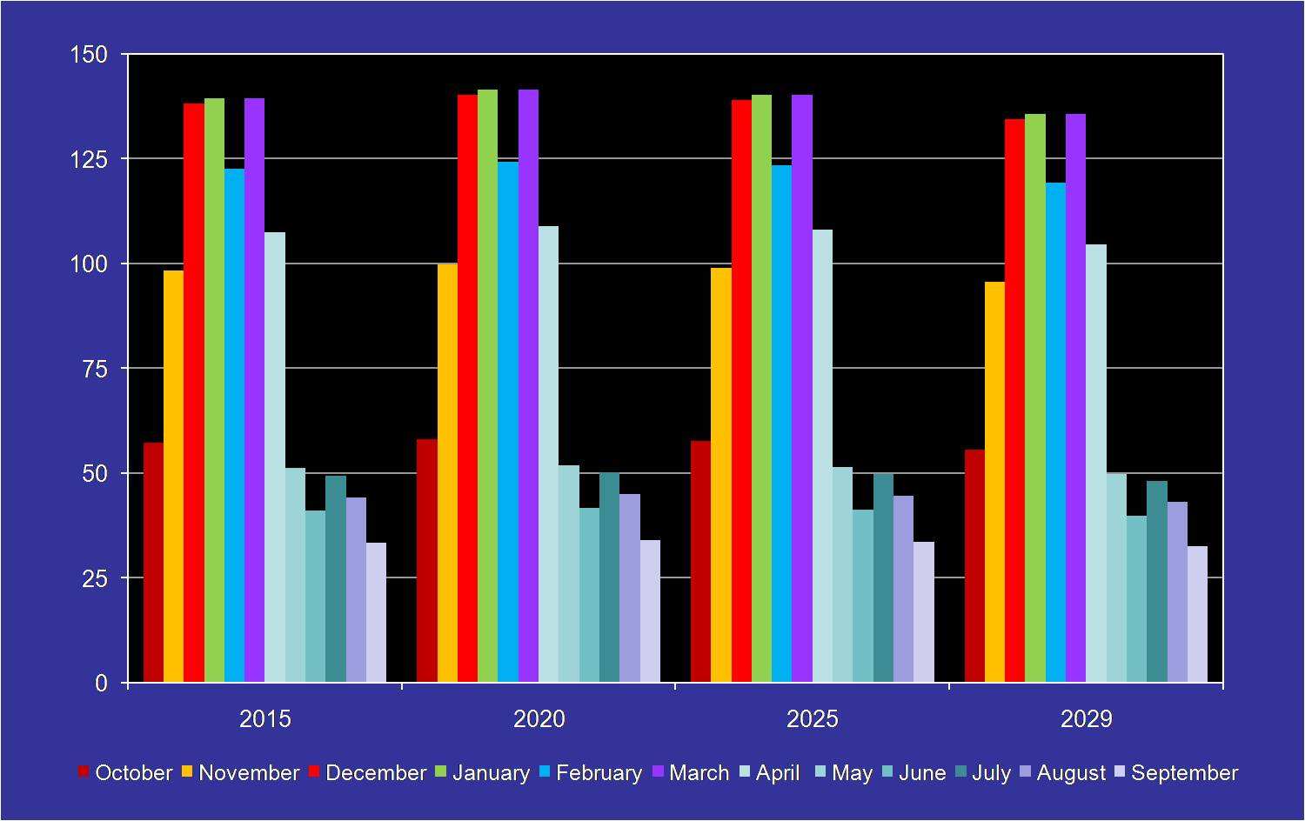
Source: B&A, 2009
Based on the projection assumptions for this analysis, most growth is envisioned to occur in a consistent seasonal pattern for regional traffic on sailings of less than 8 days. Very little growth is envisioned for the summer months, based on the projection assumptions. This is primarily due to the competition from other worldwide summer destinations whereby the revenues will continue to draw traffic out of Port Everglades’ cruise market catchments over the 20-year planning period.
Much of the long-term passenger growth (not cruise call growth) will be a reflection of the passenger capacity of the cruise vessels. This will be defined by the type of cruise sailing from the key regional homeports over the period. Further out into the projection planning period, it is more difficult to accurately reflect this outcome, due to the number of influencing factors on vessel size and capacity.
Daily Traffic Analysis. Figure 2.6-31 compares the daily passenger traffic at Port Everglades from 2005 through 2009, based on annualized cruise passenger traffic. From a passenger volume perspective, Saturday and Sunday consistently have the highest passenger throughputs and will likely continue to be the busiest cruise days throughout the 20-year planning period. This pattern is indicative of a short-cruise duration market with an emphasis on 8- and fewer-day sailings meeting the demands of the North American consumer’s vacation patterns.

Figure 2.6-31

Port Everglades Daily Passenger Traffic Comparison, 2005 – 2009

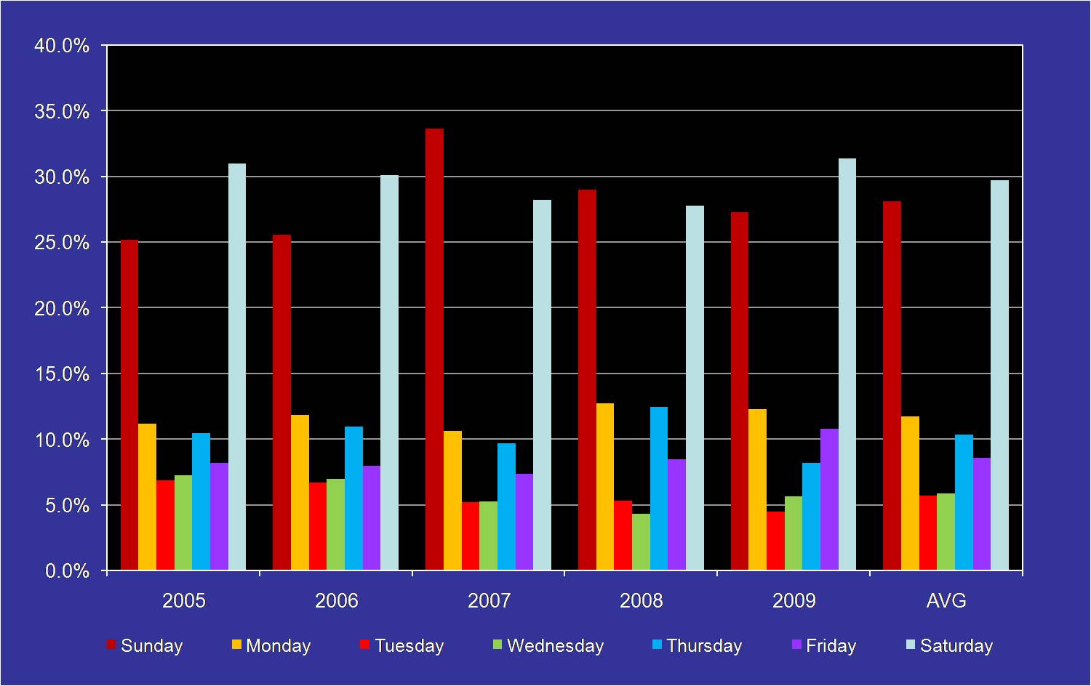
Source: B&A, 2009

As shown, Saturday and Sunday are peak traffic days for Port Everglades over the period, with an average capture rate of 29.7 percent and 28.1 percent, respectively.
Figure 2.6-32 specifically shows the overall percentage of traffic placed on the peak weekend days; the average range is 77.5 percent on weekend days and 22.5 percent on weekdays over the period. There has been some drop in peak-day capacity, reflective of traffic moving to off-peak days, which is essential for Port Everglades to maintain the support required for cruise tourism long-term.

Figure 2.6-32

Traffic Split by Percentage, 2005 - 2009

Source: B&A, 2009
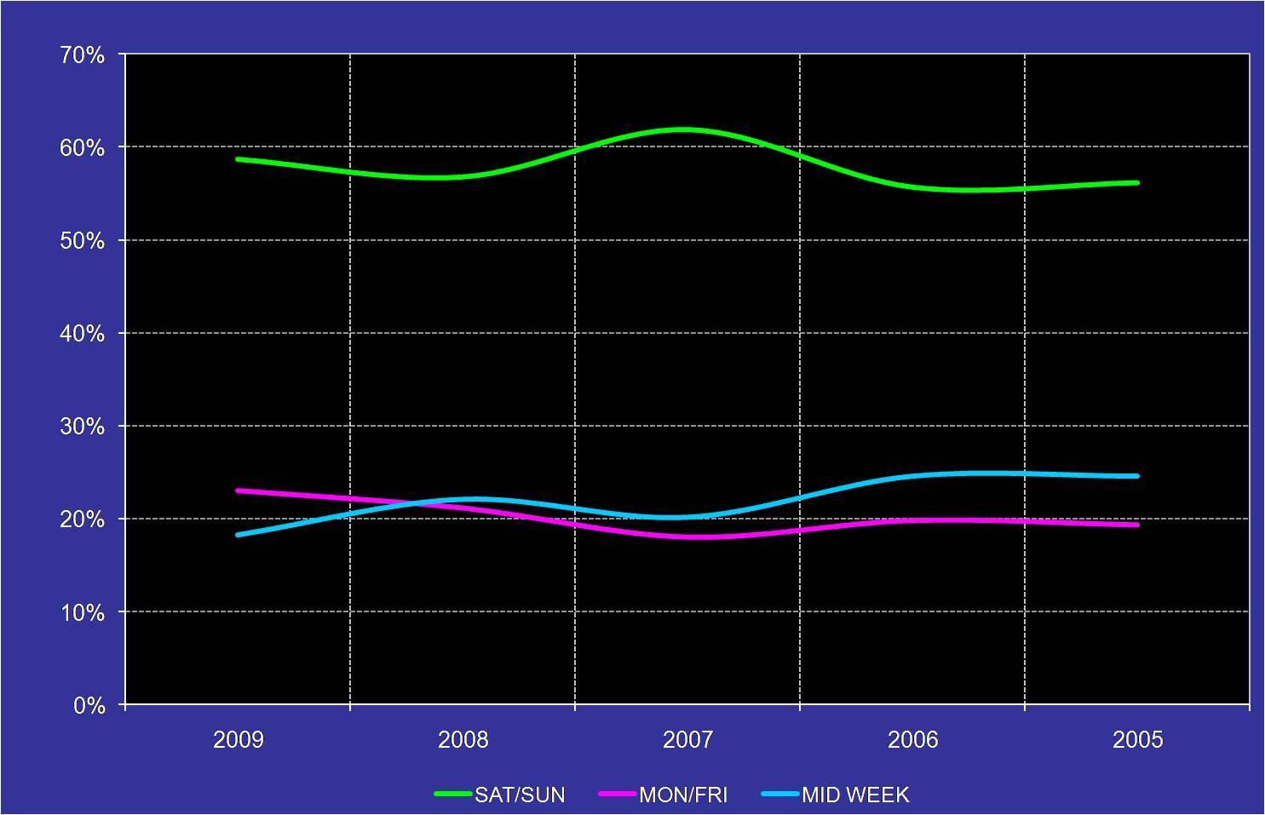
For cruise ports, the consistency of cruise traffic calling on a year-round basis is a positive attribute. This consistency allows the port to manage the cruise facilities through revenue planning, personnel scheduling, and other defined areas of operations. If cruise traffic is inconsistent on an annual basis, it poses challenges in terms of apportioning reserves to maintenance during low cruise traffic periods and places more demands on other aspects of the cruise operation such as manning, maintenance, marketing, and others.
Facility Demand. Translating cruise passenger traffic assessment and forecasts into berth or facility demand over the projection period is an essential element in the overall evaluation and planning process for Port Everglades. This process looks to identify the facility need over time and, more specifically, to focus on the timing of the facilities Port Everglades needs to accommodate future traffic demand. Facility-demand forecasting relies on identifying cruise deployment patterns, establishing future vessel sizes, and forecasting vessel calls. The projection scenarios discussed above provide a planning perspective that allows the Port’s future decision-making processes to envision the potential maximum use of existing and future required facilities, whether berth, terminal, ground transportation areas, or others. In addition, based on this assessment, Port Everglades can also manage its operations accordingly to achieve a daily traffic balance that may allow better cruise infrastructure management.
For this updated planning assessment, the process whereby berth demand is established is shown in four figures, each illustrating berth use during the weekend (Saturday/Sunday), Monday/Friday, and mid-week days for the 20-year period. It is assumed, based upon past experience, that 90 percent is the optimum berth use. Once this is achieved, an additional berth is likely needed to be able to meet the demand and allow for peak weekend use. Additionally, based upon the design vessels accommodated by Port Everglades and the new-builds moving forward, it is generally assumed that the majority of the berths should be able to accommodate the future design vessels of 1,100 feet LOA. With this size berth, the facility can also accommodate vessels of less than these requirements.
Figures 2.6-33 through 2.6-37 illustrate the anticipated demands for berths. As shown in the first two figures, 8 to 10 berths is likely not adequate for Port Everglades into the future as demand will surpass 100 to 120 percent utilization on weekends, unless cruise operators can fill the key Monday / Friday slots or weekdays. If 11 berths were available, the average peak weekend use would drop to 98 to 100 percent and below over the 20-year planning horizon.

Figure 2.6-33

Berth Demand Scenario 9 Berths, 2009 - 2029

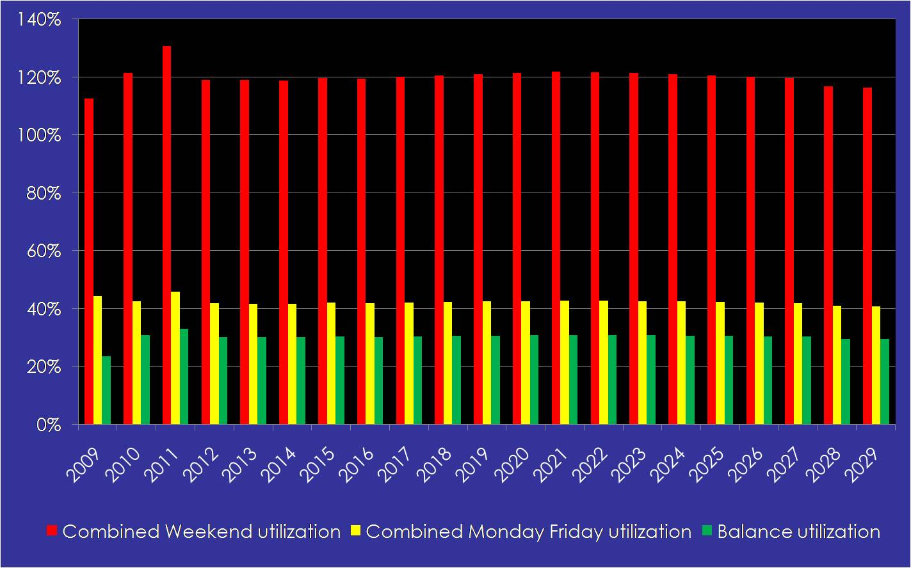
Source: B&A, 2009

Figure 2.6-34

Berth Demand Scenario 8 Berths, 2009 - 2029

Source: B&A, 2009

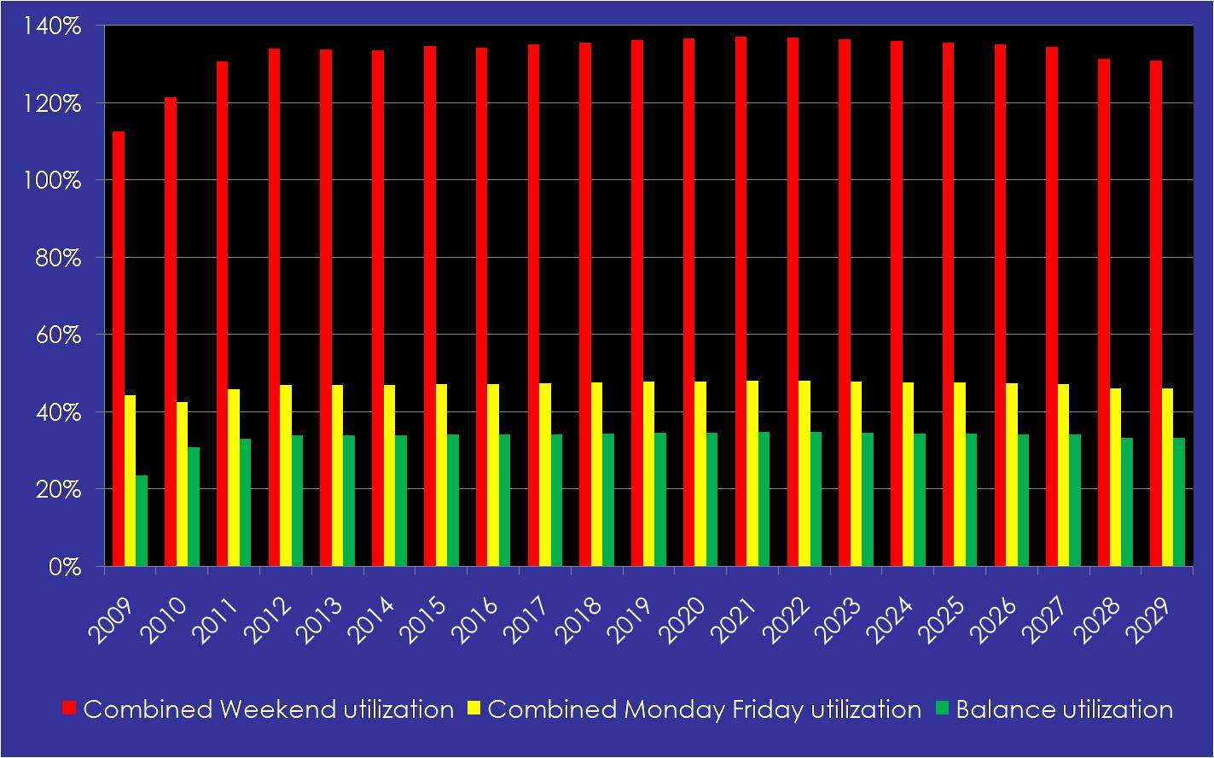
/

Figure 2.6-35

Berth Demand Scenario 10 Berths, 2009 - 2029

Source: B&A, 2009

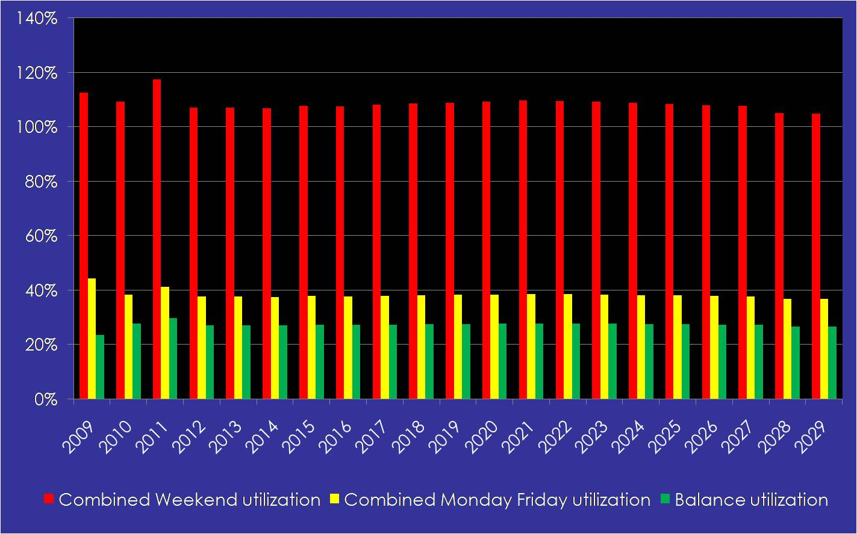
/

Figure 2.6-36

Berth Demand Scenario 11 Berths, 2009 - 2029

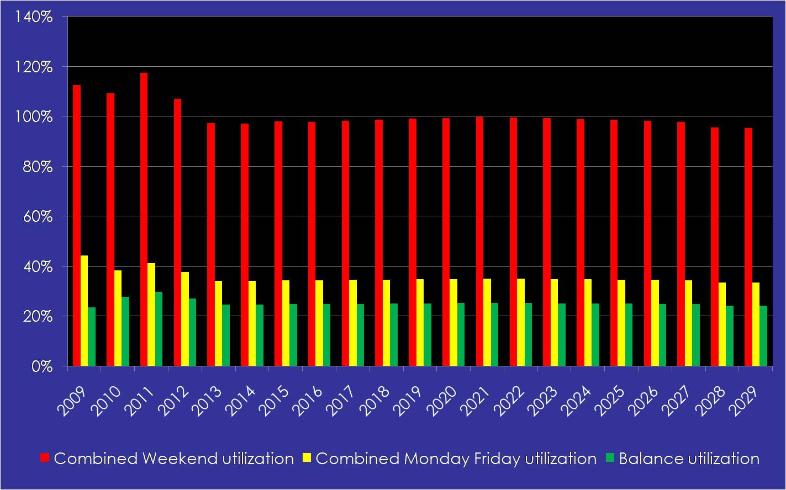
Source: B&A, 2009

Figure 2.6-37

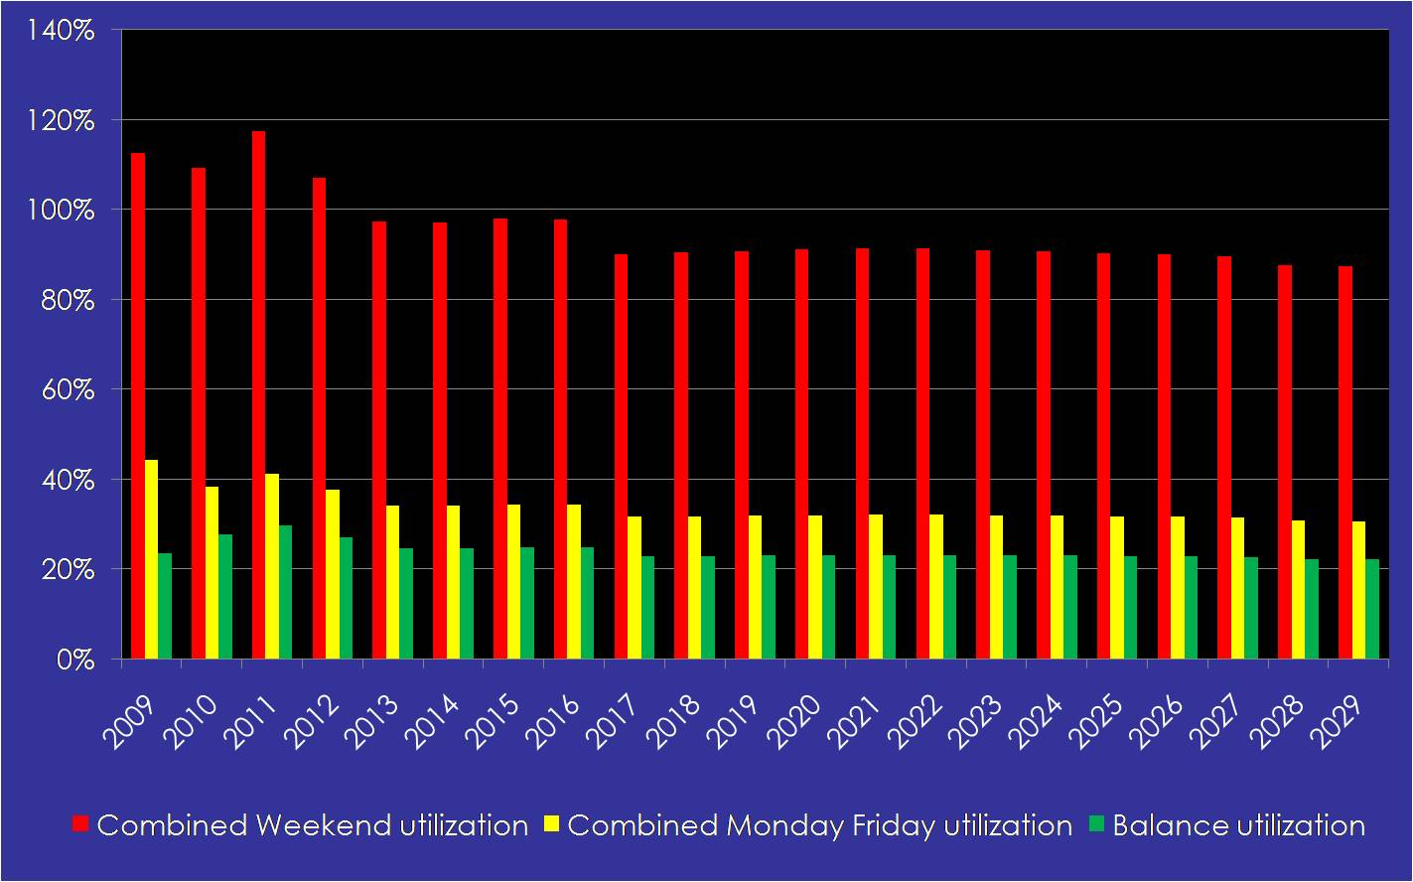
Berth Demand Scenario 12 Berths, 2009 - 2029

Source: B&A, 2009

Based on the projection approaches, new-build trends, and cruise industry deployment strategies, the development of new cruise infrastructure for Port Everglades to accommodate super post-Panamax vessels was illustrated in the 2006 Master Plan and accommodated accordingly with the development of Terminal 18. Additionally:
- Port Everglades should have the capability of handling a minimum of 8 to 9 large Panamax to super post-Panamax vessels in 2029.
- For Port Everglades, the net result of this development trend is that current and future facilities will need to accommodate larger cruise ships for the destination to remain competitive in the world and regional marketplace.
- The Port will have to offer industry operators cruise berths and terminal facilities capable of accommodating vessels of 1,100-foot-plus lengths and commensurate structural loads, with a passenger complement upwards of 4,000 to 6,000 passengers per ship.
- Based on this analysis, the Port’s unconstrained demand ranges from 11 to 12 berths over the period, of which at least 8 require LOAs of more than approximately 1,100 feet. These berths can also accommodate smaller vessels accordingly.
Table E-2, entitled Berth Demand Scenarios for Port Everglades, 2009 to 2029, in Appendix E, shows these scenarios. Currently, berth utilization on the weekend peak days at Port Everglades is more than 100 percent.
2.6.5 Cruise Vessel Growth Trends

Section Summary. In this section, cruise vessel growth trends and the relevant physical requirements of cruise facilities to accommodate the cruise vessel, operator, and passenger are presented. This section specifically illustrates the requirements of the industry relevant to the construction and deployment of cruise vessels in the worldwide cruise market and Caribbean region in general. A summary of this section is presented below:
- In February 2006, RCI announced an order for the next generation of cruise vessel – the Oasis of the Seas - for delivery in fall 2009. At 220,000 gross tons (GT), this vessel is approximately 43 percent larger than their current largest vessel -- the Freedom of the Seas, delivered in spring 2006. The sister ship - Allure of the Seas – will be delivered in 2010. Both vessels will be deployed to Port Everglades. In addition, NCL contracted with Aker Yards to build one new 150,000-GT, 325-meter LOA cruise vessel (Norwegian Epic) capable of accommodating more than 4,200 passengers and crew. A single vessel is scheduled for delivery in 2010.
- As of August 2009, 38 new cruise vessels with a total capacity of 95,128 berths were scheduled for delivery over the next four years (2009 through 2012). As of the date of this assessment, some of these vessels have already been delivered. For comparison purposes, in December 2006, the forward cruise vessel order book contained 29 vessels with a berth capacity of approximately 85,000. The average new vessel currently on order carries 2,222 passengers.
- The evolution of the cruise vessel has been one of the principal mechanisms propelling industry growth. Over the past five years, the newest and most popular generation of vessels continues to have greater passenger volumes, beams, and lengths to accommodate the area needed for large-scale outside cabin development. These vessels range in length from 965 to 1,200 feet and have an average lower-berth passenger complement of between 1,950 and 3,600.
- For Port Everglades, the net result of the trends in cruise vessel development is that current and future pier, terminal facilities, and upland support areas will need to accommodate these large cruise vessels to remain competitive in the regional marketplace and be able to fully accommodate the service requirements of the future generation of cruise vessels. This will include the ability to offer industry operators facilities and venues capable of accommodating a passenger complement upwards of 5,000 to 6,000 passengers per vessel.
- Selection of a model design vessel or vessels dictates a programmatic response for Port Everglades, one that will allow the Port to meet industry needs, maintain competitiveness in the region, and plan homeport operations, as deemed viable and within best practices, established in conjunction with stakeholders, to remain a marquee cruise homeport and destination.

Cruise Vessel New-Build Program. Cruise operators have been highly successful in introducing new vessel inventory and developing on-board products that generated sustained interest in cruising. Lines continually work to improve the quality and quantity of on-board experiences with more diverse food and beverage venues, entertainment and deck activities, meeting and conference facilities, and recreation areas.
Among the largest of their efforts is the continuous repositioning of smaller older vessels and the creation of larger and more lavish vessels furnished with veranda-style outside cabins, grand central atriums, health spas, and other amenities found in the best land-based resorts. This trend became the norm in the mid-1990s and has continued as cruise brands introduce innovative products and services on the newest vessels to further differentiate themselves from the competition and generate renewed public interest in cruising. Consumers generally meet each new vessel launch with enthusiasm, and ultimately, increased passenger bookings.
The review of future vessel deliveries, as shown in Tables 2.6-5 and 2.6-6, remains the primary tool used to project future passenger growth. Responding to cruise passenger demand, cruise operators continue to order new vessels, although at a more restrained pace than observed at the peak of vessel orders in the late 1990s and early 2000s.
Since the advent of American Classic Voyages, nine small ships have also been ordered for the first time in more than five years. Pearl Seas Cruises has ordered one ship, which is being built at Irving Shipbuilding in Halifax, Nova Scotia. Due to cruise operator concerns with the outfitting of the vessel, it is assumed the Pearl Mist will be delivered later than originally scheduled in 2009. Seabourn Cruises has also ordered three cruise vessels with a 450-passenger capacity. The other small ships have been ordered by Ponant Cruises and Silver Sea Cruises.
For European consumers, cruise operators have added numerous products and services to meet the needs and expectations of the cruise passenger. These additions include themed areas, pubs, multiple dining areas, expanded casinos, and on-board interior themes.
Delivery of the larger 80,000-GT plus vessels into the worldwide cruise fleet is far from over. More than half of the vessels delivered or on order since 2006 exceed the 100,000-GT mark, with this number increasing annually.
For Port Everglades, the net result of the vessel development trends is that current and future pier, terminal, and upland areas will need to accommodate these large cruise vessels for the destination to remain competitive in the regional marketplace and be able to fully satisfy the service requirements of the future generation of cruise vessels. This will include the ability to offer industry operators facilities and venues capable of accommodating a passenger complement upwards of 5,000 to 6,000 persons per vessel.

Based on cruise line interviews and an understanding of the cruise line market, these next generation vessels (more than 1,050 to 1,400 feet) will be, for the most part, purpose-built and intended for specific deployments – most likely the Caribbean and Mediterranean. They become much more of a destination than even today’s vessels.

Table 2.6-5

Large Cruise Vessels on Order Worldwide, August 2009

Source: www.cruisecommunity.com and B&A, 2009
Cruise Operator | Vessel Name | Gross Tonnage | Lower Berth Capacity | Cost (US$ Millions)
2009
AIDA Cruises | AIDAluna | 68,500 | 2050 | $390
Carnival Cruise Lines | Carnival Dream | 130,000 | 3652 | $668
Celebrity Cruises | Celebrity Equinox | 122,000 | 2850 | $641
Costa Cruises | Costa Luminosa | 92,700 | 2260 | $528
Costa Cruises | Costa Pacifica | 112,000 | 3004 | $579
MSC Cruises | MSC Splendida | 133,500 | 3300 | $550
RCI | Oasis of the Seas | 220,000 | 5400 | $1.24bn
2010
AIDA Cruises | AIDABlu | 71,000 | 2174 | $513
MSC Cruises | MSC Magnifica | 90,000 | 2568 | $548
Celebrity Cruises | Celebrity Eclipse | 122,000 | 2850 | $698
Costa Cruises | Costa Deliziosa | 92,700 | 2260 | $548
Cunard Line | Queen Elizabeth | 92,000 | 2092 | $708
Holland America Line | Nieuw Amsterdam | 86,000 | 2100 | $567
NCL | Norwegian Epic | 150,000 | 4200 | $940
Oceania Cruises | Marina | 65,000 | 1260 | $530
P&O Cruises | Azura | 116,000 | 3076 | $535
RCI | Allure of the Seas | 220,000 | 5400 | $1.4bn
2011
AIDA Cruises | unnamed | 71,000 | 2174 | $557
Carnival Cruise Lines | Carnival Magic | 130,000 | 3652 | $738
Celebrity Cruises | unnamed | 118,000 | 2850 | $798
Costa Cruises | unnamed | 114,200 | 3012 | $726
Disney Cruise Line | unnamed | 124,000 | 2500 | $899
MSC Cruises | MSC Meraviglia | 93,000 | 2550 | $548
Oceania Cruises | unnamed | 65,000 | 1260 | $530
2012
AIDA Cruises | unnamed | 71,000 | 2174 | $565
Celebrity Cruises | unnamed | 122,000 | 2850 | $798
Costa Cruises | unnamed | 114,200 | 3012 | $726
Disney Cruise Line | unnamed | 124,000 | 2500 | $899
MSC Cruises | MSC Favolosa | 93,000 | 2550 | $548
Source: www.cruisecommunity.com and B&A, 2009

Table 2.6-6

Small Cruise Vessels on Order Worldwide, August 2009

Source: www.cruisecommunity.com and B&A, 2009

Cruise Operator | Vessel Name | Gross Tonnage | Lower Berth Capacity | Cost (US$ Millions)
Pearl Seas Cruises (2009) | Pearl Mist | 8,700 | 210 | $64
American Cruise Lines (2009) | Independence | 3,000 | 104 | $30
Seabourn Cruises (2009) | Seabourn Odyssey | 32,000 | 450 | $250
Silver Sea Cruises (2009) | Silver Spirit | 36,000 | 540 | $300
Ponant Cruises (2010) | L’Boreal | 10,600 | 264 | $150
Ponant Cruises (2010) | L’Astral | 10,600 | 264 | $150
Seabourn Cruises (2010) | Seabourn Sojourn | 32,000 | 450 | $250
Sea Cloud (2010) | Sea Cloud Hussar | - | 136 | $140
Seabourn Cruises (2011) | Unnamed | 32,000 | 450 | $250
Source: www.cruisecommunity.com and B&A, 2009

Design Vessel Requirements. The design vessel requirements for Port Everglades’ homeport operations established in the 2006 Port Master Plan are still valid. Using these design parameters, consideration can be given to each of the primary infrastructure categories required to support the Port’s cruise operations, with specific emphasis on the primary infrastructure of entrance channels, turning basins, berths, passenger terminals, ground transportation areas, and other elements used to service cruise vessels in port.

Port Everglades presently has demand to serve Panamax, post-Panamax and super post-Panamax vessels. Through the stakeholder outreach process, several lines — both regional and international — indicated their intention to place larger vessels in the Caribbean region, specifically at Port Everglades, in the short- to mid-term.
For Port Everglades, the ability to accommodate ships of more than 150,000 GT and approximately 1,100 feet LOA is a key factor in its ability to serve as a primary regional cruise homeport. Based on the projection and berth utilization assessment, Port Everglades should have the capability of handling a minimum of 8 to 9 large Panamax to super post-Panamax vessels in 2029. Thus, the net result of the vessel development trend is that current and future facilities will need to accommodate larger cruise ships for Port Everglades to remain competitive in the world and regional marketplace.

Suggested Design Vessels for Port Everglades. The previous discussion, cruise line stakeholder outreach, and data provided throughout this section had, as one of their purposes, the discovery of what design vessel(s), hard infrastructure, and cruise operational planning scenarios Port Everglades should envision for the future. Selection of a model design vessel(s) dictates a programmatic response for the Port, one that will allow it to meet industry needs, maintain competitiveness in the region, and plan homeport operations as deemed viable and within best practices established in conjunction with stakeholders to remain a marquee cruise homeport and destination. Recommended is a series of design vessels for the Port over time, as illustrated in Table 2.6-7.
These design vessels incorporate the features of the various classes that are becoming industry standards, including the Destiny, Grand, and Voyager as well as the super post-Panamax Freedom, Oasis, and F3 classes. Based on these design vessel characteristics, a series of marine requirements for future master planning cruise infrastructure development is provided:
- Berth: Minimum – 1,100-foot LOA, preferably 1,300-foot LOA; 32-foot depth (excludes the Queen Mary 2 which requires 37 feet).
- Apron: 75 feet wide.
- Pier: 150- to 250-ton bollards.
- Utilities: Water, telecommunications, power (alternative marine power).
- Navigation: Adequate maneuvering; turning basins - 1.2 to 1.5 times LOA.

Table 2.6-7

Recommended Design Vessels for Port Everglades

Source: B&A, 2009

Vessel Parameter | Design Vessel 1 (Panamax) |  | Design Vessel 2  (post-Panamax) | Design Vessel 3  (super post-Panamax)
Passengers |  | 2,000 to 2,600 | 3,000 to 4,000 | 4,200 to 5,200
Crew |  | 850 | Up to 1,200 | 1,200
Gross Registered Tons |  | Up to 100,000 | 100,000 to 140,000 | 150,000/ + 70,000
Length Overall (feet) |  | 900 to 985 | 985 to 1,100 | 1,150 to 1,300**
Beam (feet) |  | Up to 118 | Over 118  (generally 130 to 165) | 150 to 200***
Draft (feet) |  | Up to 28 | 28 to 32.8* | 28 to 32
Air Draft (feet) |  | Less than 195 | Up to 210 | 210+
Note: Suggested design vessels represent primary ranges of the majority of vessels within these categories. *Queen Mary 2 has a vessel draft of 32.8 feet, but requires 37 feet of water.
** Estimated specifications based on Freedom; Oasis, and F3 Class Vessels - 3 primary vessels.
*** Design Vessel 3 LOA beam estimates based on scale of vessels presented to date.

North American operators are those lines that market the majority of their vessels to North American consumers in the US and Canada. Similarly, European and Asian operators market a majority of their vessel offerings to each respective consumer market
Scenarios present berths in net terms and envisage some withdrawal of older vessels, and thus, capacity from service. This occurs on a fairly regular basis at present. New Safety of Life at Sea (SOLAS) rules in 2010 will inevitably hasten the withdrawal from service of a considerable number of vessels that were built at or before 1969. This series of SOLAS rules looks to eliminate all wood from cruise vessels. At present, there are no vessels in the North American fleet that do not meet these regulations.
Carnival Corporation owns two land-based tour operations in Alaska - Holland America Tours and Princess Tours - which operate buses, hotels/lodges, and train cars for sightseeing.
RCCL owns Royal Celebrity Tours in Alaska.
CLIA 2008 Cruise Market Profile, April 2008. Study conducted by TNS Travel & Transport.
CLIA data, while one of the best data sets available, are not comprehensive as they largely exclude non-members. Membership, however, is not exclusively North American and many European-based lines increasingly choose to join CLIA. Member lines, as of 2008, include: AMA Waterways, American Cruise Line, Azamara Cruise Lines, Carnival Cruise Lines, Celebrity Cruises, Costa Cruises, Crystal Cruises, Cunard Line, Disney Cruise Line, Holland America Line, Hurtigruten, Majestic America Cruise Line, MSC Cruises, Norwegian Cruise Line, Oceania Cruises, Pearl Sea Cruises, Princess, Regent Seas Cruises, Royal Caribbean International, Seabourn Cruise Line, Seadream Yacht Club, Silversea, Uniworld River Cruise Collection, and Windstar Cruises.
Operations in seasonal cruising regions usually occur over a 6- to 8-month period, with vessels repositioned to another seasonal or year-round cruising region during the off-season. By example, operations in Alaska typically occur from late April through late September, with vessels transiting the Panama Canal to return to the Caribbean to offer cruise itineraries through the winter.
While the groups are presented in general terms, in reality and depending upon the size of the cruise line, the groups can include several departments and decision-makers as part of the overall destination and itinerary selection process.

