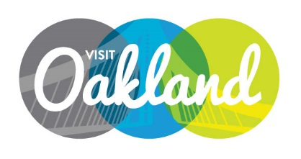

Board of DiRECTORS Meeting Agenda
Tuesday, Feb 02, 2016 10am to 12 pm
Location: Executive Inn
Michael LeBlanc, Chair, Presiding

- Call to Order M. LeBlanc

- Public Comment/Announcements

- Guest Introductions

- Overview of Discussion M. LeBlanc

- Bylaws Update

- OTBID Update

- Personnel Update

- Adjournment M. LeBlanc

NEXT MEETING: Tuesday, February 16th – 4 pm / Location: Claremont Hotel and Spa

Thank you Mark Hochstatter for hosting us today!

