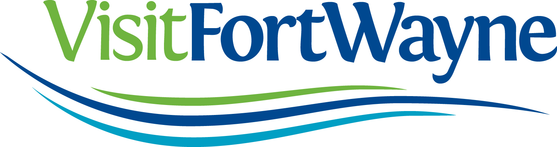

Visit Fort Wayne is looking for unique voices to help provide Fort Wayne “Insider” information for our visitor-focused community blog (found at VisitFortWayne.com/blog)

Bloggers are paid $20 per article, $25 for articles containing new original photography. Content will focus on events, restaurants, activities and attractions that are of interest to our visitors – but we want your unique “insider” perspective. Bloggers and Visit Fort Wayne work together to determine blog topics to cover.

* We are also looking for video bloggers who would submit their posts in video fashion.

Interested parties should fill out the application below and submit it to:

Jessa Campbell
Marketing and Communications Coordinator * Visit Fort Wayne
927 S. Harrison Street * Fort Wayne, IN 46802

jessa@visitfortwayne.com
(260) 424-3700
_________________________________________________________________________________________________

GENERAL INFORMATION

Name

Email Address

Brief Bio/Background

BLOGGING EXPERIENCE

Do you currently have a blog or run another social media effort?

What is the address of your blog or website?

What do you think that your followers rely on you for/look to you for?
FORT WAYNE EXPERIENCE

What are a few things that you would like to write about in our community?
What do you think are the things that are of biggest interest to our visitors?

What type of niche/perspective would you write from (family activities, arts/entertainment, nightlife, other??)?

WRITING/MARKETING EXPERIENCE

Do you have any marketing or writing experience? Please explain.

How much advance notice would you require for assignments?

OTHER

Anything else that you would like us to know?

Thank you very much for your interest in Visit Fort Wayne
and in promoting our community!

