CRM Instructions
Updating Social Media

http://extranet.denver.simpleviewcrm.com

Viewing Your Member Record
Depending on your access levels, there are various items that can be viewed under your Member Record:
- Social Media

Currently, VISIT DENVER has the capabilities to add the following Social Media feeds to your member listings:
- TripAdvisor*
- Facebook
- Twitter
- Yelp*
- Pinterest

*As of today, VISIT DENVER does not have the capability to show both your TripAdvisor feed and your Yelp feed. Please choose one or the other.
VISIT DENVER hopes to have the capabilities to add the following Social Media feeds to your member listings in the future:
- Blog
- GooglePlus
- Instagram

To add your TripAdvisor feed:
Your TripAdvisor Reviews are something that VISIT DENVER manages for you. If you have difficulty with your TripAdvisor feed, or if you would like to turn it off or on, please contact VISIT DENVER staff to take care of this.

Please contact Lindsey Riddle at lriddle@visitdenver.com

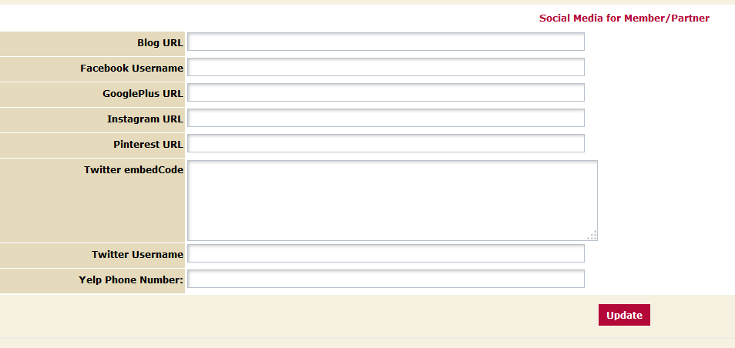

To add your Facebook feed:
- Enter your Facebook URL. To find this, go to your Facebook homepage. Copy and paste the URL. Formatting example: https://www.facebook.com/VisitDenverMembers

To add your Twitter feed:
- Access your Twitter Embed code through your Twitter account settings. (For more detailed instructions on where to find this code: http://screencast.com/t/XqDQXUGX)
- Copy your embed code from Twitter and paste exactly as it appears into the Twitter embedCode field.
Formatting example: <a class="twitter-timeline" href="https://twitter.com/username" data-widget-id="466725830886821888">Tweets by @Username</a>
<script>!function(d,s,id){var js,fjs=d.getElementsByTagName(s)[0],p=/^http:/.test(d.location)?'http':'https';if(!d.getElementById(id)){js=d.createElement(s);js.id=id;js.src=p+"://platform.twitter.com/widgets.js";fjs.parentNode.insertBefore(js,fjs);}}(document,"script","twitter-wjs");</script>
To add your Yelp feed:
- Please enter your business phone number exactly as it appears on your Yelp account. Formatting example: (303) 111-1111
To add your Pinterest feed:
- Enter your Pinterest URL. To find this, go to your Pinterest profile page. Copy and paste the URL. Formatting example: http://www.pinterest.com/visitdenver/

