Day | Class | Time | Centre | Price
Weekdays | Swimming | 9.00am - 4.00pm | All Waltham Forest pools | FREE
Monday | Short Tennis | 11.00am -1.00pm | Waltham Forest Feel Good | £3.55
 | Seated Exercise | 11.45am - 12.30pm | Chingford Leisure Centre | £5.45
 | Seated Exercise | 12.00pm – 1.00pm | Score Leisure Centre | FREE (Leyton Orient Trust)
Tuesday | Badminton | 10.00am – 12.00pm | Waltham Forest Feel Good | £3.55
 | Aerobics Basics | 10.30am – 11.30pm | Leyton Leisure Centre | £5.45
 | Aerobics Basics | 11.00am – 1.00pm | Walthamstow Leisure Centre | £5.45
 | Table Tennis | 11.00am – 1.00pm | Walthamstow Leisure Centre | £3.00
Wednesday | Pickleball | 11.00am – 1.00pm | Score Leisure Centre | £3.55
 | S. Tennis & Pickleball | 11.30am – 1.00pm | Peter May Sports Centre | £3.55
 | Table Tennis | 11.30pm – 1.00pm | Chingford Leisure Centre | £3.05
 | Seated Exercise | 12.30pm - 12.45pm | Leyton Leisure Centre | £5.45
Thursday | Walking Football | 10.30am - 11.30am | Waltham Forest Feel Good | £5 - (Age UK WF)
 | Gentle Walk | 11.00am - 11.45am | Score Leisure Centre | FREE (Leyton Orient Trust)
Friday | Short Mat Bowls | 10.30am - 12.30pm | Waltham Forest Feel Good | £3.55
 | Circuits Training Basics | 11.30pm - 12.30pm | Chingford Leisure Centre | £5.45
 | S. Tennis & Pickleball | 12.00pm - 2.00pm | Waltham Forest Feel Good | £3.55
 | Table Tennis | 12.30pm - 2.00pm | Chingford Leisure Centre | £3.05
Weekend | Swimming | 2.00pm - close | All Waltham Forest pools | FREE
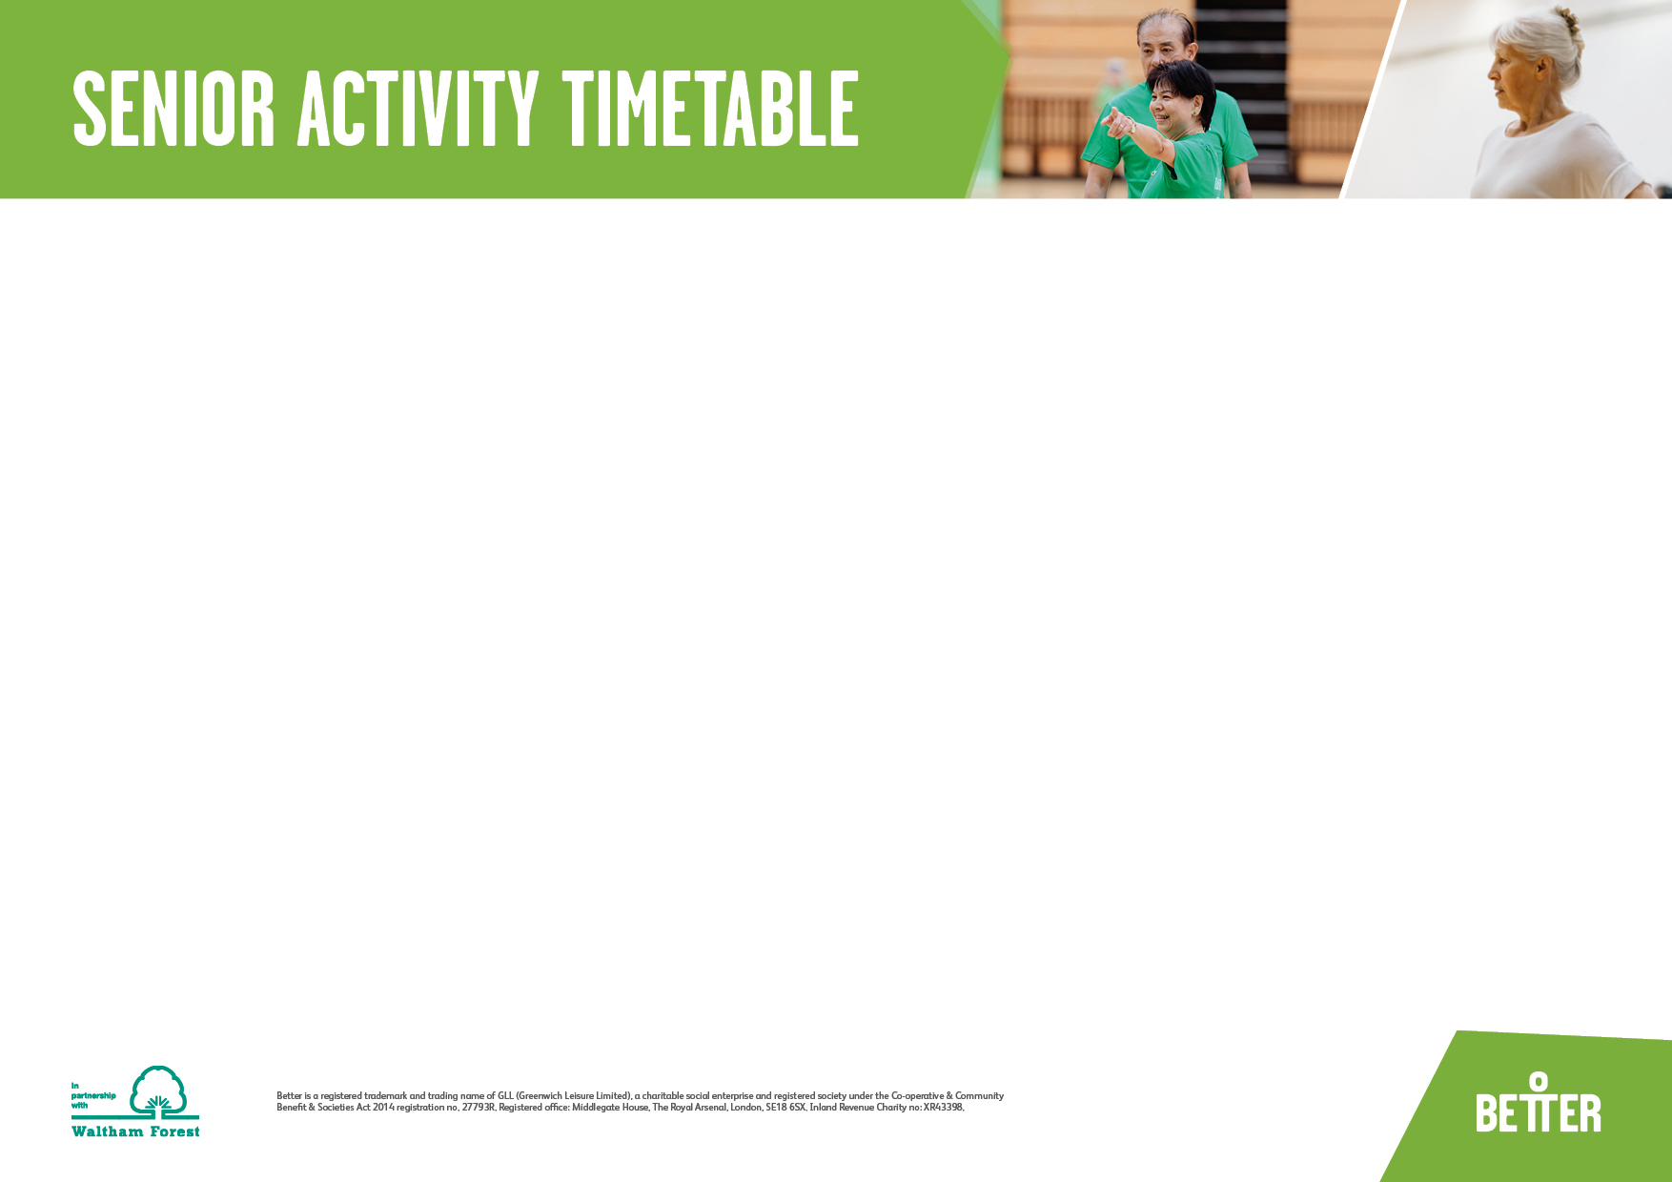
Activities suitable for ages 60+. Prices are for Senior Pay as You Go card (annual price of £12.30)

